Centre No: 10856 Candidate No: 5184

# Contents

Contents

Contents 1

Analysis 2

Problem and background 2

Interview with stakeholders 2

Existing programs 2

Proposed solution 2

Success criteria for proposed solution 2

Design 2

Decomposition diagram 2

User interface 2

Algorithms and data structure 2

Test data to be used during iterative development 2

Developing the coded solution 2

Implementing the questions 2

Implementing the scores 6

Implementing the report 11

Implementing the levels 12

Creating the login, signup and database 16

Testing to inform development 18

Evaluation 25

Evidence of success criteria 25

Limitations and improvements with stakeholders’ interview 32

References 33

# Analysis

## Problem and background

There’s a limited number of resources available for A level Economics. Specifically, there’s a scarce amount of revision quizzes available that focuses on the multiple-choice questions. However, I aim to produce a revision quiz aimed at AQA A Level Economics, that’s based on the multiple-choice questions, and will provide an efficient and interactive method of revision. This lends itself to a computational problem because the program would take in the users’ details and be able to calculate the scores and output the questions and answers. I will be using problem decomposition by breaking the problem down into parts, for example, I will be focusing on the logins and database for one part and the other focusing on outputting the questions and answers, then combining them together.

Stakeholders

The stakeholders for the project will be A Level Economics students studying AQA as the revision quiz is designed specifically for AQA A Level Economics. The project will be suited to their needs as they are able use it as a method of revision. I will be interviewing them to gain a better understanding of the problem and to be able to propose a solution using the stakeholders’ views.

## Interview with stakeholders

**How do you typically revise for Economics?**

To revise for Computer Science, mind maps are typically used with active recall. In addition, watching videos are helpful, as well as writing essay plans with class notes.

**What is effective about this method?**

By using past papers, exam skills can be developed whilst, simultaneously working on improving subject knowledge. Additionally, mind maps are more useful for trying to organise different topics into their chapters, whilst expanding or refreshing existing knowledge. This combination is effective because it helps to revise content, which can be difficult to remember, however, this method also helps to work on exam technique. Furthermore, essay plans are helpful for becoming familiar with important key terms and potential essay questions that could come up.

**What could be improved about this method?**

The method can be quite repetitive and laborious, as it’s not engaging so it’s easy to lose focus. This makes it hard to feel motivated and to continuously revise with full concentration, which in turn, may affect grades and exam results.  In addition, it takes a lot of time to prepare the notes

**How could a revision quiz based on past papers’ multiple choice help you revise?**

It helps with being more familiar with the language that is used in the exam and helps test the knowledge gained while revising. Furthermore, being familiar with multiple choice exam style questions are useful especially with common questions asked in a slightly different context.

**What revision techniques are effective and useful?**

Revision techniques like repetition and feedback or comments on knowledge

**What features would be appealing for the revision quiz?**

There could be sections for different topics, exam boards, years of exam papers used or a progress bar.

Observation

It can be observed that revising key terms and being familiar with the language is important for the exam, however it can be time consuming to revise and go over notes. Additionally, revision techniques like feedback on knowledge can be useful and some features the revision quiz could implement are sections for different topics or a progress bar.

## Existing programs

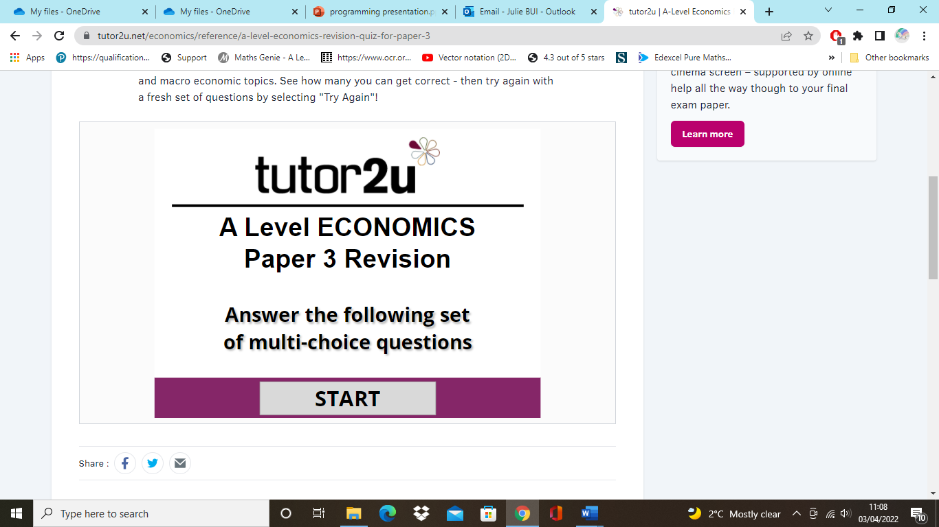

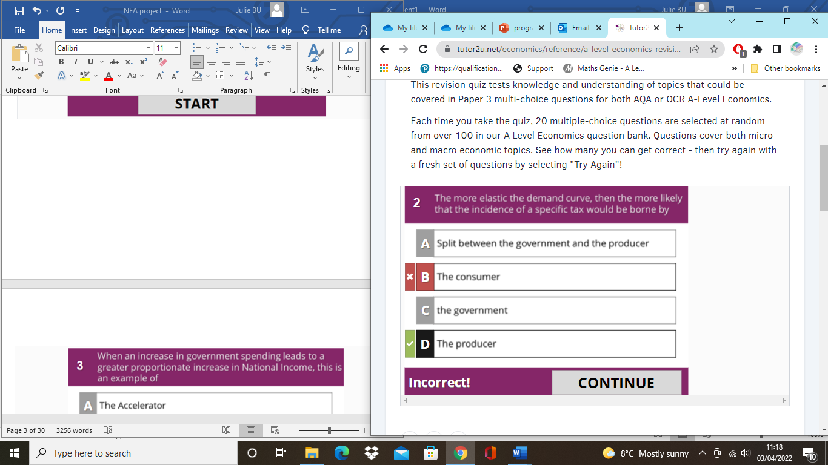

An example of a program designed for A Level Economics is the tutor2u revision quiz. [1] It is a multiple-choice quiz based on the paper 3 covering both Micro and Macro topics, and asks 20 multiple-choice questions at random. It is an effective source for revision because it informs the user what the correct answer is if they’ve gotten it wrong and it also displays the score at the end, with a “Try again” button so users can start the quiz all over again. Although, the revision quiz has content for both AQA and OCR Economics, this means the questions may not be catered for each user and the quiz doesn’t have levels, which means users won’t have the ability to progress.

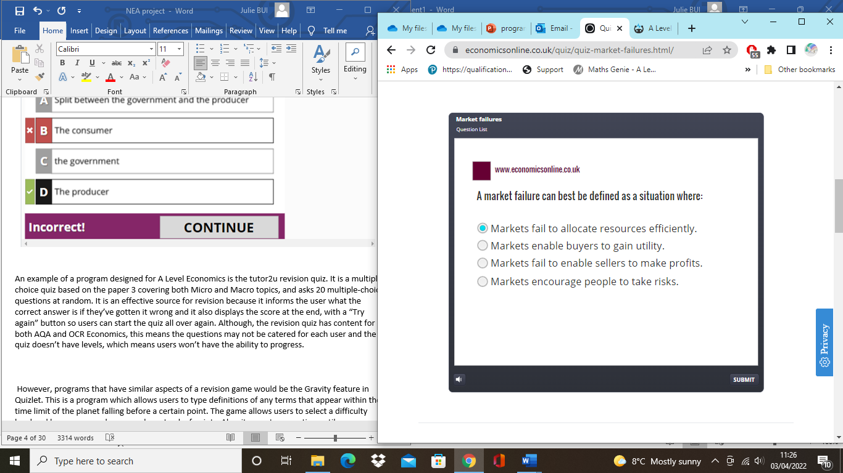

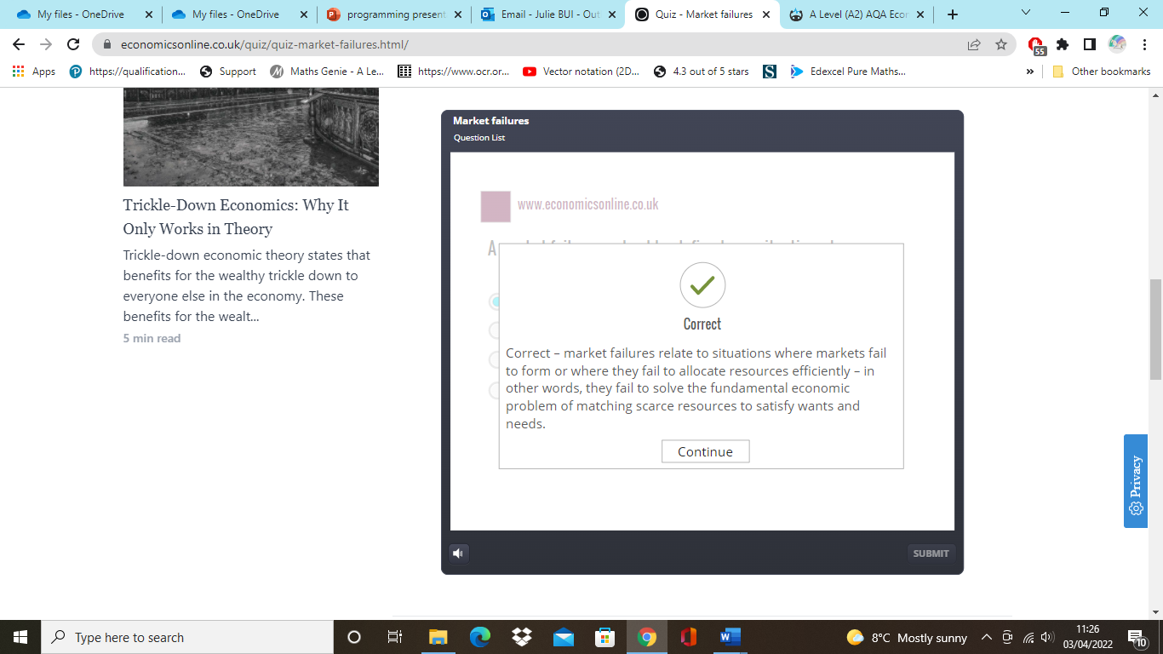

On the other hand, another example of a revision quiz for A Level Economics is the Economics online revision quiz.[2] It is similar to the tutor2u revision quiz where the questions are based on the multiple-choice questions in the past papers. What’s useful about the revision quiz is that it displays feedback if users have gotten a question right. This means users are able to reinforce their knowledge and it gives them a greater understanding. Furthermore, it’s an effective revision quiz because users are given two attempts to answer correctly, this allows users to work on their mistakes and try again. However, the revision quiz is limited because if users chose the wrong option, the revision quiz only displays what the correct answer should be at the end. This means users are not able to improve on their wrong answers whilst completing the revision quiz

Suitable approaches based on research

Overall, I can conclude that the revision quiz should let the users know whether they’ve gotten a question right or wrong, and if so, they should be informed of what the correct answer should be whilst they’re still completing the revision quiz. In addition, what lacked from both the revision quizzes in the examples was the content was not specific to an exam board, this means the revision quiz I program should be based on just the AQA exam so the content is more relevant. Furthermore, what could be added onto the report at the end for both the quizzes is, the report could have included the number of correct and wrong answers.

## Proposed solution

The revision quiz is aimed at providing an efficient software used for revision. This should be done by catering the revision quiz so it’s based on the AQA A Level Economics past papers so the content is relevant and applicable.  In addition, it will an efficient software for revision, because the multiple-choice questions tend to be similar over the years. This will help prepare the students for their upcoming exams as they’ll be more familiar with the terminology used in the questions. The program will be implemented by outputting the multiple choice questions which users should be able to select and they will be informed of whether their answer is correct or wrong. A report will be outputted at the end with the users’ scores and number of correct and wrong answers. This allows users to be aware of what they need to improve on and their current level. Furthermore, the revision quiz will be specific to each user’s needs because they will be able to choose between an easy, medium or hard level. In addition, users will be able to create an account with their username and password.

Limitations

A limitation may be that the revision quiz doesn’t focus on the essay side of the subject, since Economics is an essay writing subject. However, the multiple-choice questions are included in the exam paper and may be a part of the paper that is overlooked, since students spend the majority of their revision focusing on the essay questions. This means that the revision quiz will be helpful because it will enable students to revise the multiple-choice questions which are useful in reinforcing knowledge and understanding content.

## Success criteria for proposed solution

The success criteria for the proposed solution are listed below. It will be used throughout the project as a guide.

* The program will be able to output the questions with the multiple-choice options
* Users should be able to select the option they choose and the program should be able to move onto the next question successfully
* The program will output whether it’s the right or wrong answer
* Users will be informed whether the option they choose is right or wrong
* If it’s wrong users should be informed of what the correct answer should be
* The program will calculate the score
* If users select the right answer, the score will implement by one
* The score will be shown in the report
* Levels will be implemented
* Levels include an easy, medium and hard level
* This allows users to cater the revision quiz according to their own needs and level
  + There will be a report at the end
* This allows users to be informed of their score so they are aware of the number of questions they’ve gotten right and wrong
* There will be a database of users’ details
* This includes users’ first name, last name and they will be able to create their account with their own username and password
* Questions will be based on the past papers for AQA Economics
* This will allow the revision quiz to be catered to students studying AQA A Level Economics so the content is more relevant.

# Design

## Decomposition diagram

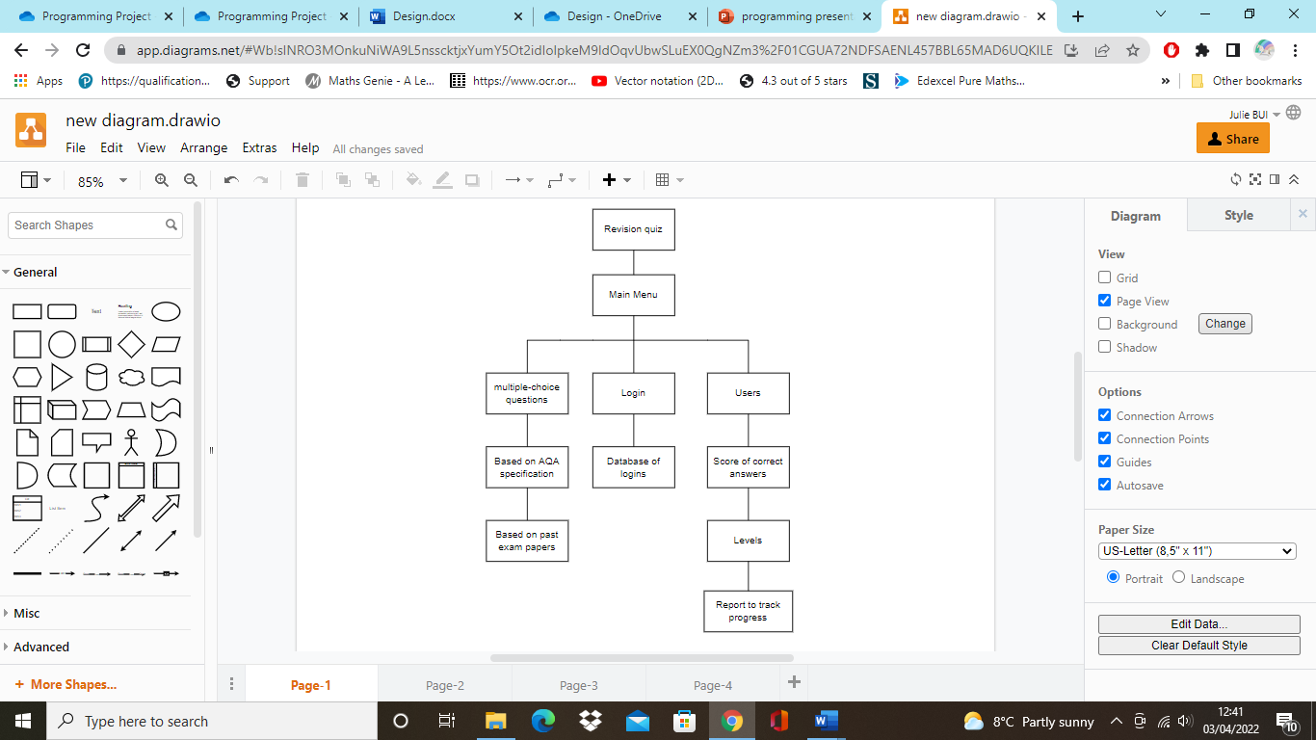

The diagram above shows the decomposition diagram of the revision quiz. It has the main menu where users are able to login and their details will be stored onto a database. In addition, the multiple-choice questions are based on the AQA specification and past papers. Furthermore, users will be shown their score of the correct answers and they will be able to choose their levels and track their progress with the report at the end. The logins and database are broken down separately from the multiple-choice questions and users, because it will be a separate section of the revision quiz where users can just register their account. Additionally, the multiple-choice questions are broken down separately from the logins and users, because the questions will be worked on independently as I would have to create them from the past papers first.

## User interface

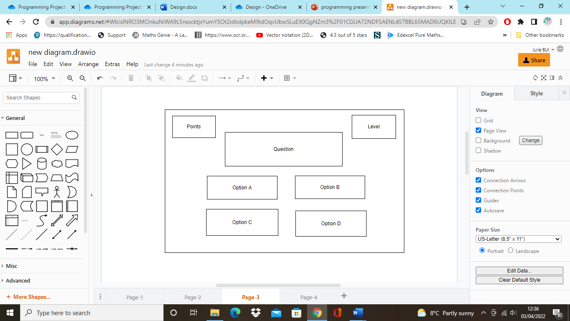

The digram shows the design of a multiple-choice question. In th left corner users will be able to see their points, this is so they’re able to monitor their progress and in the right corner will be the level the user has chosen. The question will be placed in the middle since this is the main focus, and the options for the multiple choice will be placed at each corner, this is to maximise the space as the options will be spaced apart.

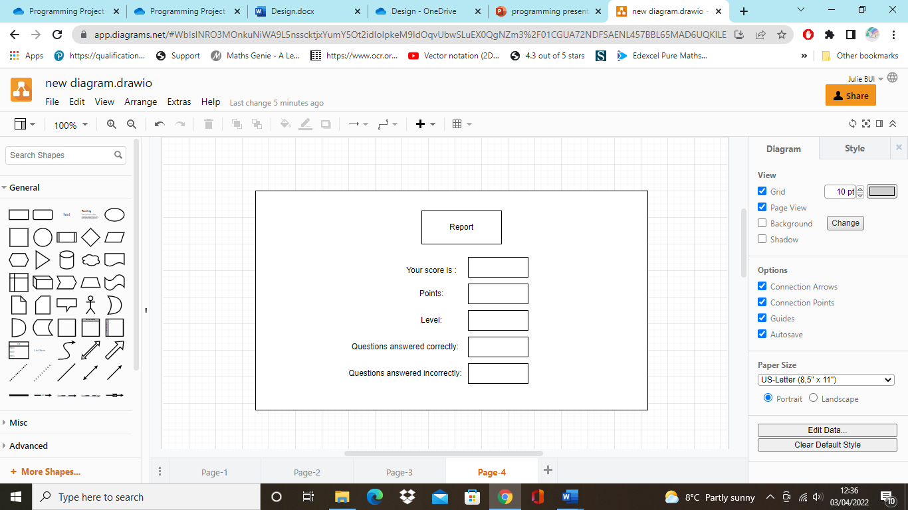

Another diagram shown is the report diagram. It includes the users’ score, points, level and questions answered correctly and incorrectly. This is so users are aware of their score and their development.

## Algorithms and data structure

*def calculate_score():*

*score = 0*

*if user_ans == answer [question]:*

*score += 1*

*output (“Correct answer”)*

*else:*

*output (‘Wrong answer!’ f’ The correct answer is {answer[question]}’*

The algorithm above is an example of a score algorithm that could be implemented. The score is set to 0 and if the user chooses the right answer, then the score implements by one, else, it will inform the user the answer is wrong and what the right answer should be.

|  |
| --- |
| Quiz |
| userScore: Integer  userAns: integer  userLevel: string  question: string  answer_q: string  report: string |
| calculate_score()  getuserAns()  getuserLevel()  displayQuestion()  displayAnswer()  display_report() |

The diagram above shows the class Quiz that will be implemented in the program. Its attributes are the users’ score, users’ answers, users’ level, the questions, answers and the report. The behaviours of the class Quiz will be to calculate the score, obtain the users’ answers and level and be able to display the questions, answers and report.

## Test data to be used during iterative development

The table below shows the aims of the revision quiz of what I expect to program, linked to the success criteria.

|  |  |  |
| --- | --- | --- |
| Number | Success criteria | Expected output |
| 1 | The questions will output with the multiple-choice options | * Each question will output successfully with the corresponding options * Users will be able to select their answer * After the user clicks the next button, the next question will output successfully |
| 2 | Th program will output whether it’s the right or wrong answer | * If the user selects the right answer the program will let the user know it’s right * If the user selects the wrong answer, the program will let the user know it’s wrong and what the wrong answer will be |
| 3 | The program will calculate a score | * The score will be calculated whilst the program is running and implements with each correct answer * The score will be shown in the report |
| 4 | Levels will be implemented | * There will be a levels window where users are able to select between an easy, medium and hard level * If the user selects the button the corresponding questions will appear of each level |
| 5 | There will be a report at the end | * After the user has finished the last question, a report will appear showing the score and number of correct and wrong answers |
| 6 | There will be a database of users’ details | * After the user registers their account, their details should output in the database * The user should be able to login with the username and password they created |

# Developing the coded solution

## Implementing the questions[3]

To implement the questions, I decided to add them in the main file as shown below.

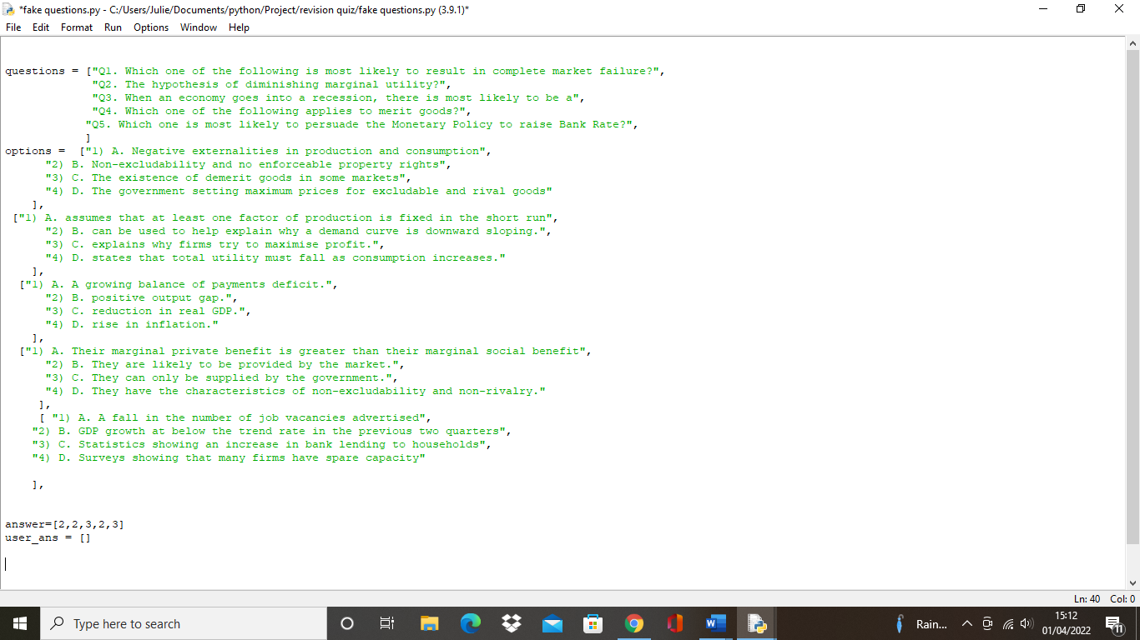

However, since this was the beginning stage, I only had a few questions but begun to realise it’d be more efficient if the questions and answers were held in a separate file as it was taking up a lot of space. With this in mind, I decided to hold the questions and answers in a separate json file named “data.json” and the revision quiz would output the questions and answers held in the file.

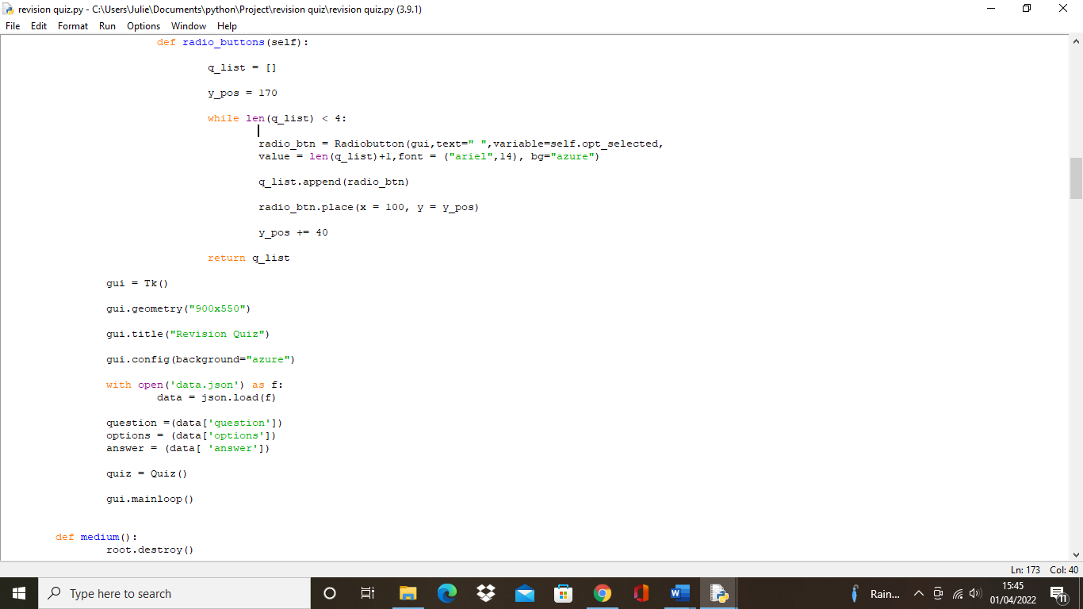

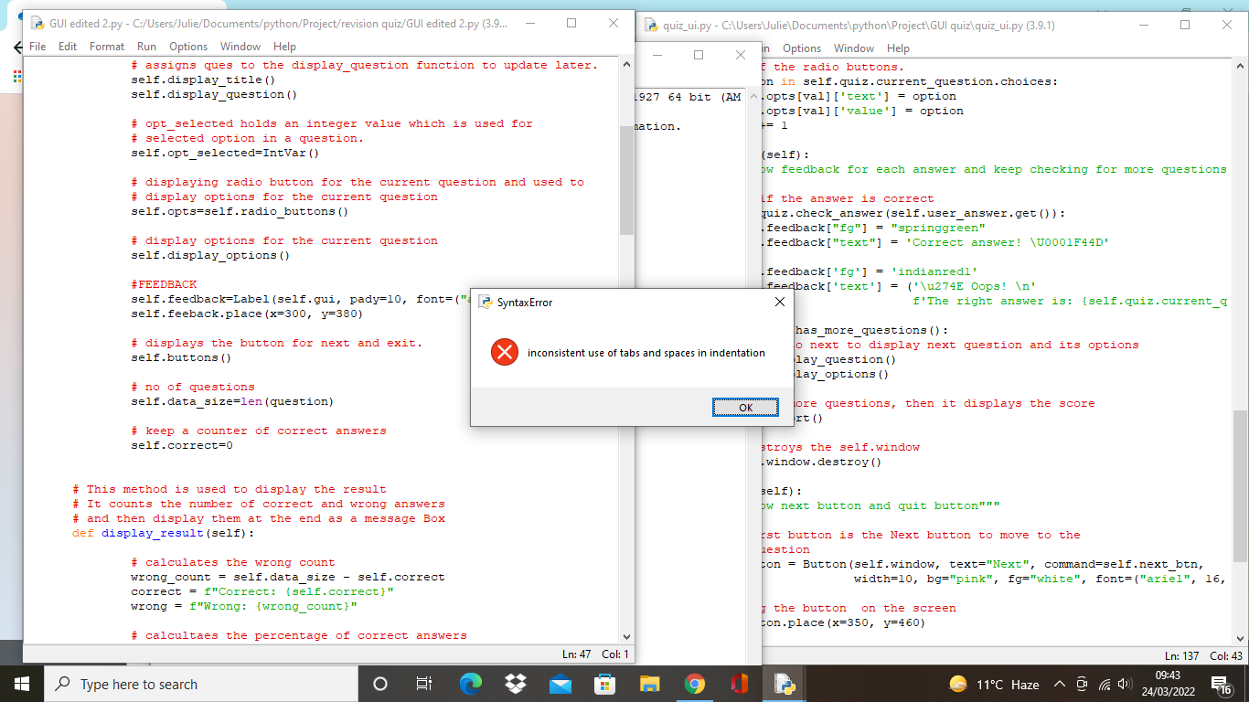

Whilst running the program, a syntax error occurred stating the “inconsistent use of tabs and spaces in indentation”. This was due to the copy and paste from the questions from the main file to the json file, to fix this, I had to go on the edit tab and click on untabify region.

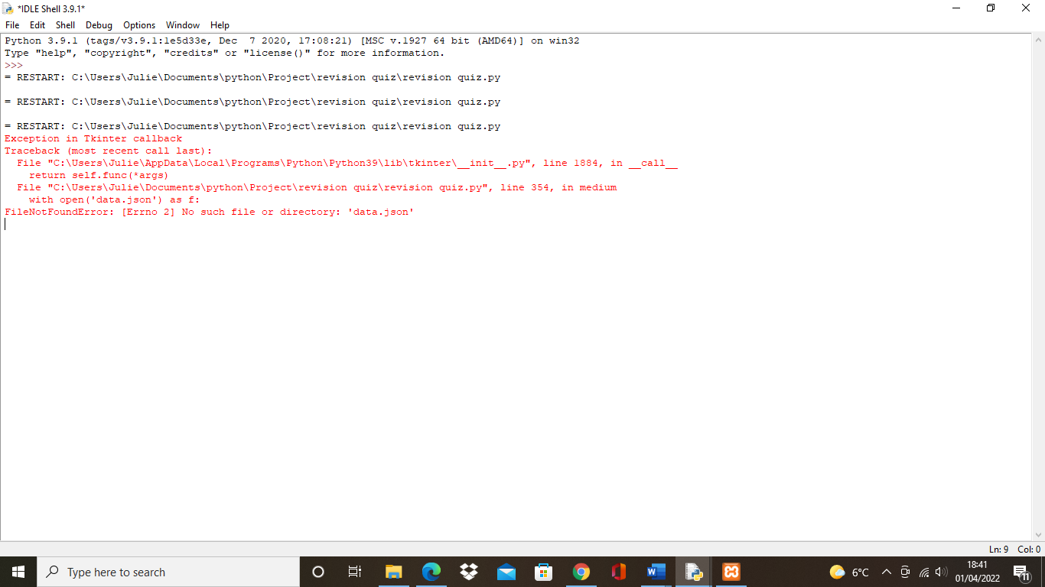

After, an error occurred where the file was not found. To solve this, I had to save the “data.json” file in the same folder as the main program.

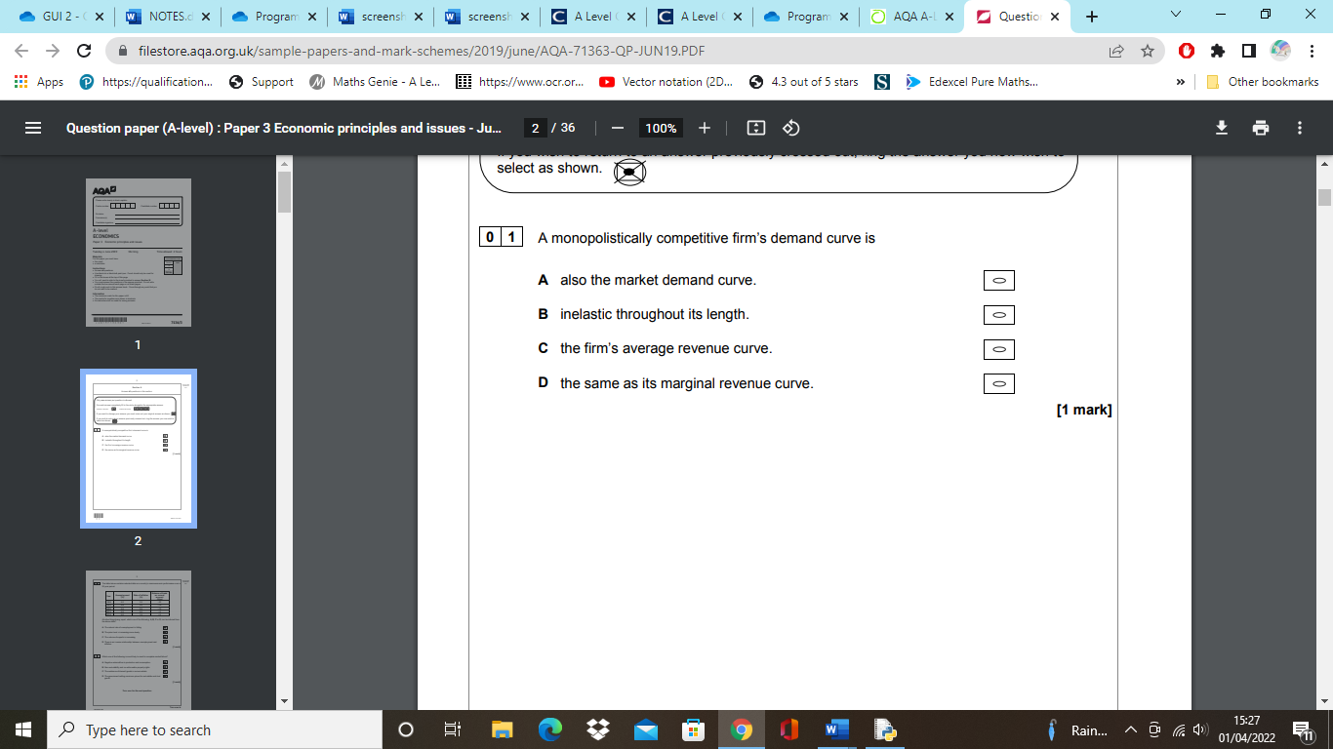

As outlined in the success criteria, the questions are based off the past exam papers, an example shown above.[4] Initially, I intended to output them with the layout shown in the design section but thought it’d be more suitable if the revision quiz has the questions laid out like the exam papers, so users are more familiar. For example, the multiple-choice options would be laid out aligned on top of each other, instead of positioned in each corner at the bottom like in the design section. This led me to program the questions in the layout like below.

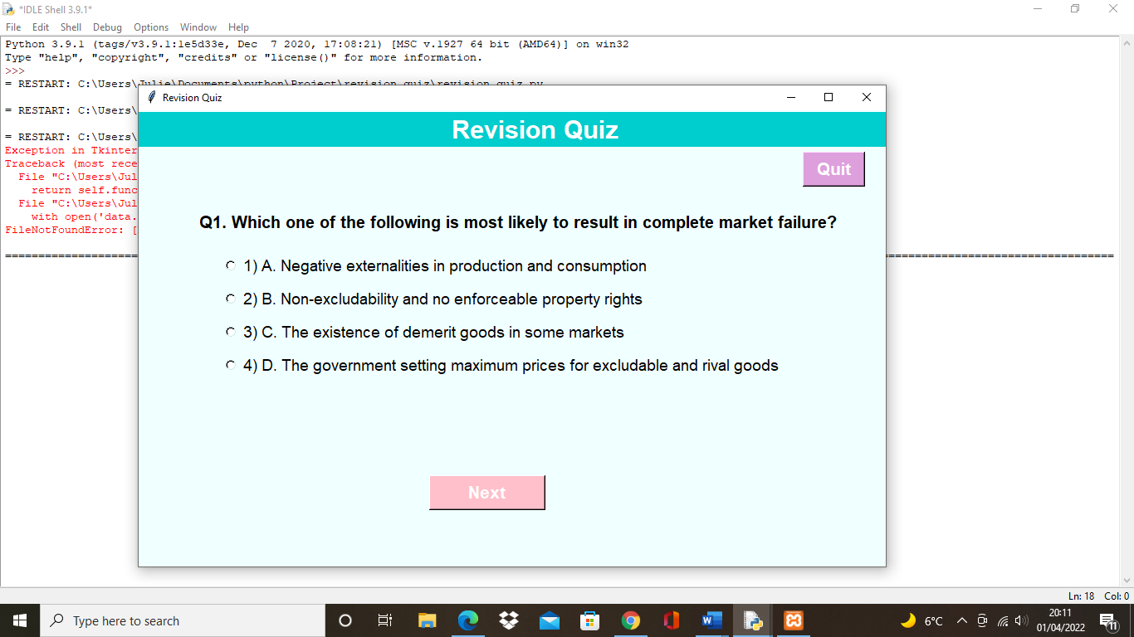

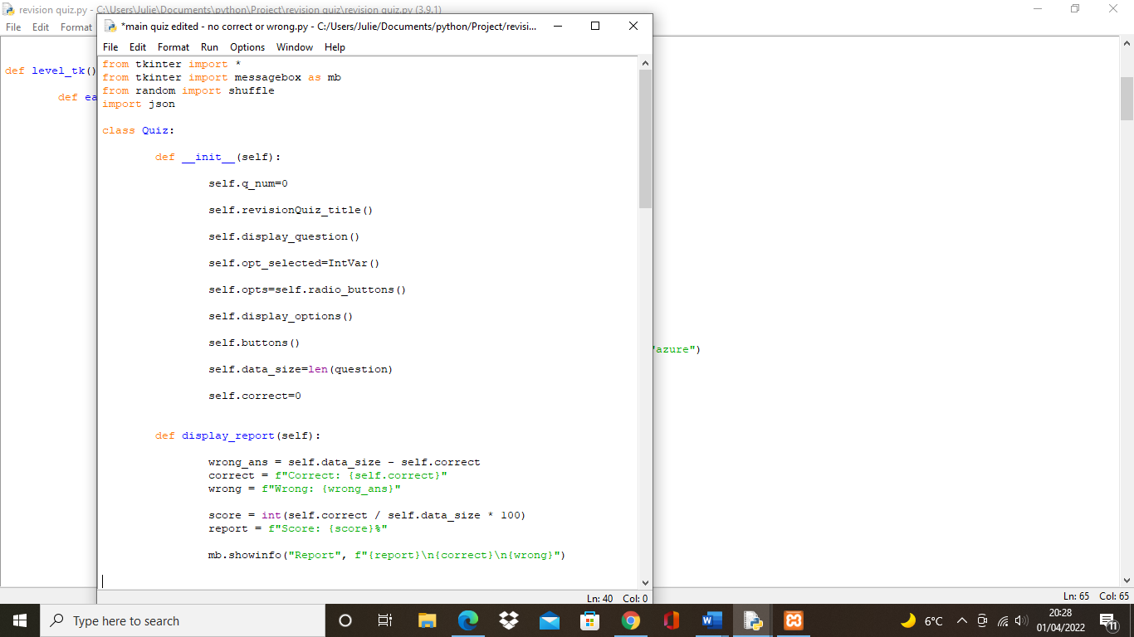

To program this, I set the question number to 0 and initialised the display_question() and display_options() within the class quiz.

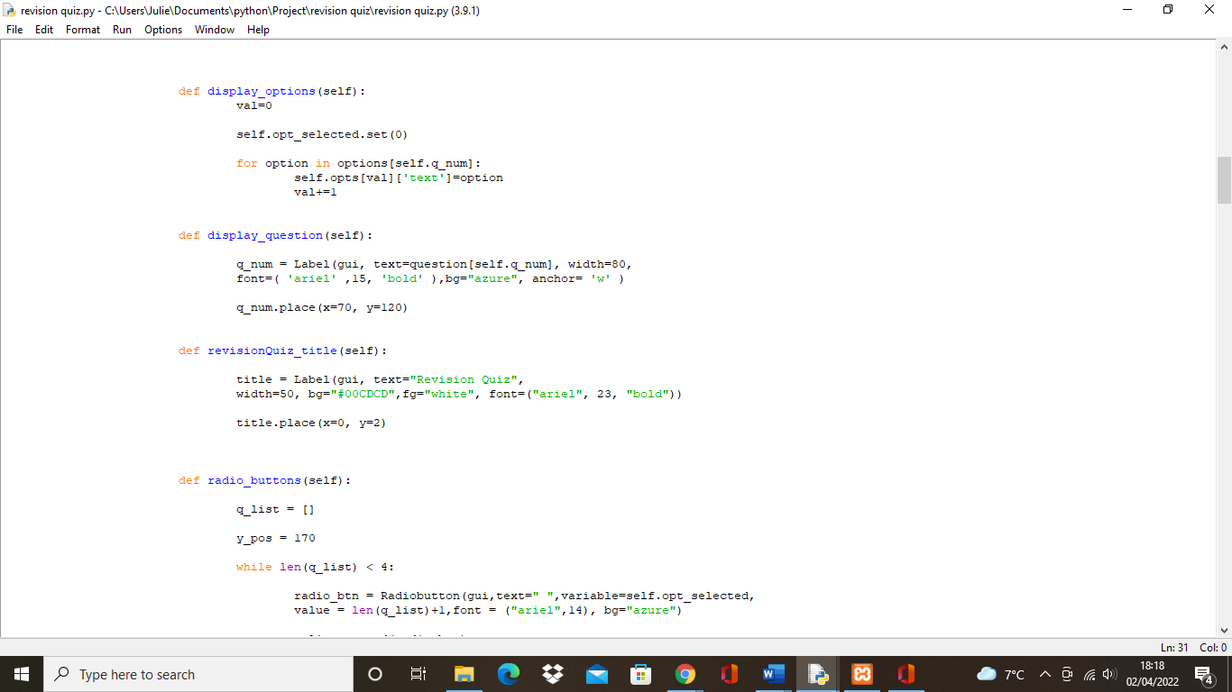

The display_options deselects the multiple choice options and loops over the options through the question number. It also updates the options for the current question of the radio button

The display_question and revisionQuiz_title displays and sets the properties for the question and title

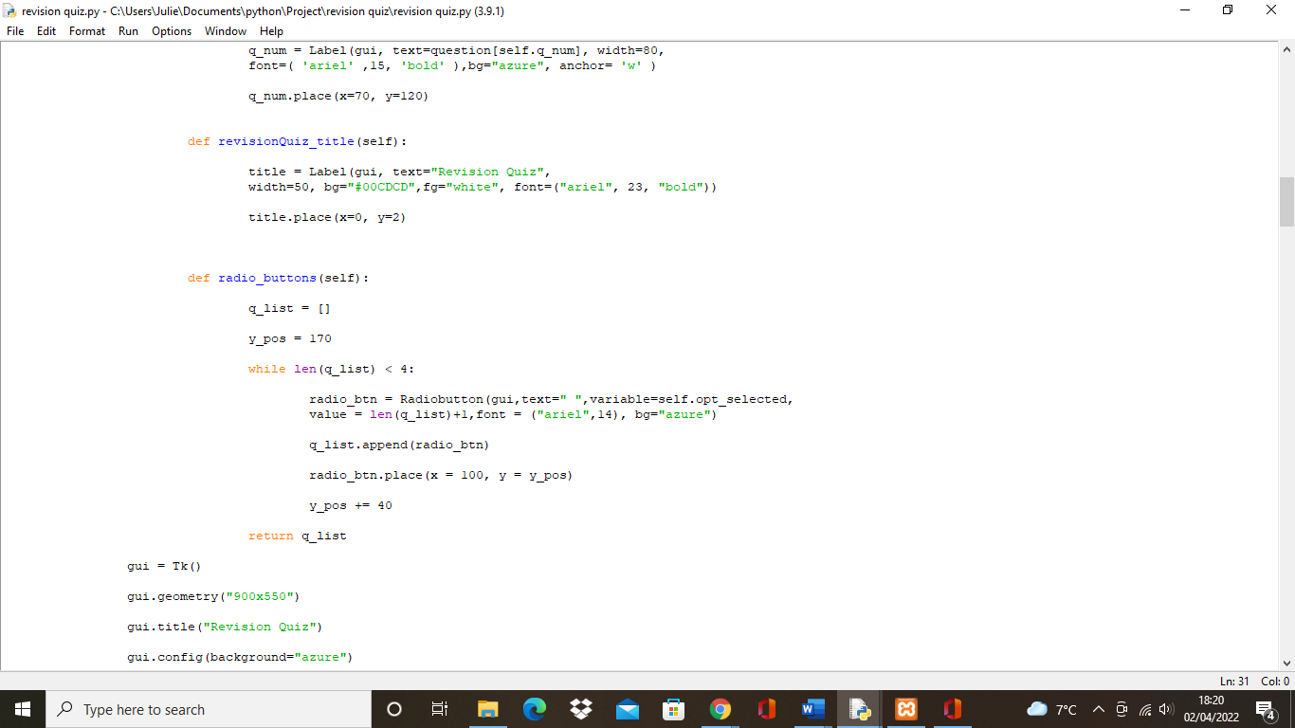

The def radio_buttons(self) returns a list of radio buttons which are used to add the options at the specified position and properties

## Implementing the scores



Firstly, I set the number of correct answers to 0 in the class Quiz so it can be accumulated after, whilst the opt_selected will hold an integer value which is used for the selected option in a question.

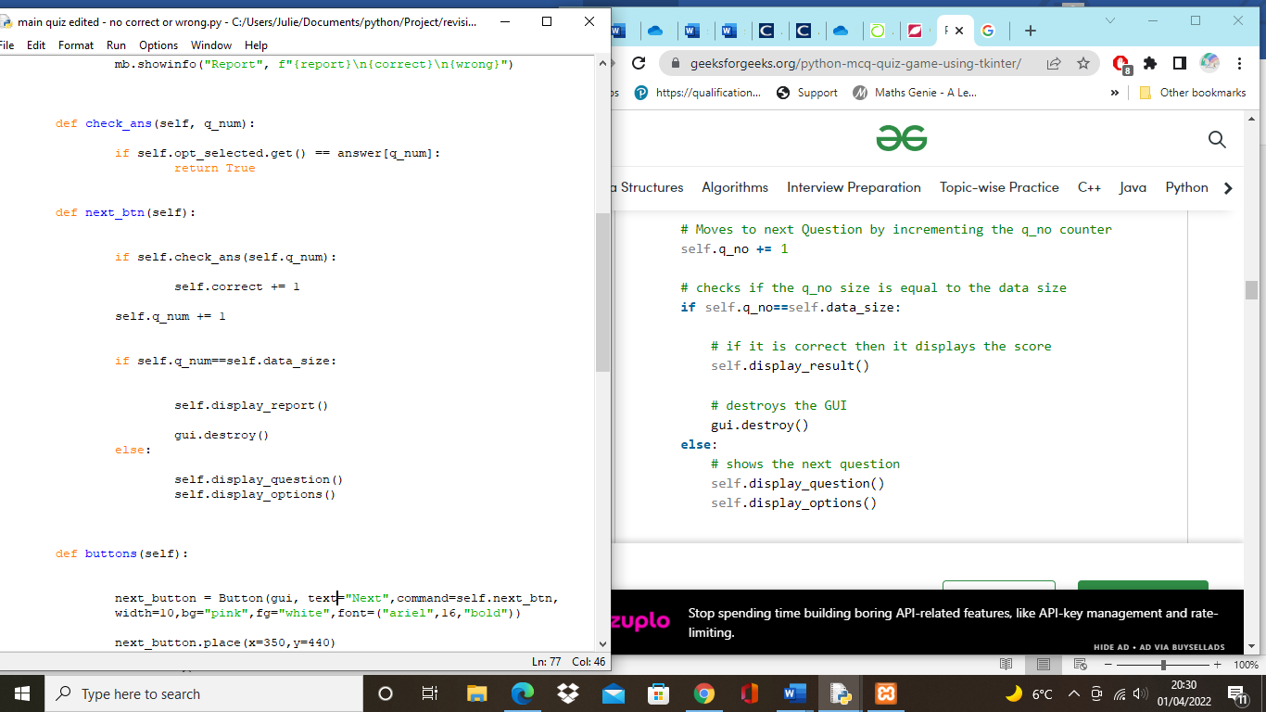

To check whether the user answers correctly or not, the function check_ans compares the option the user selects with the correct answer in the file.

When the user clicks the next button, the correct count will implement by 1 if it’s correct and the question number will also implement by 1.

If the question is the last one then the program will display the report, otherwise it shows the next question.

However, the quiz should be able to output whether the answer is right or wrong. Thus, I first had to create the self.feedback label and place and I tried to output “Correct” when the answer is right.

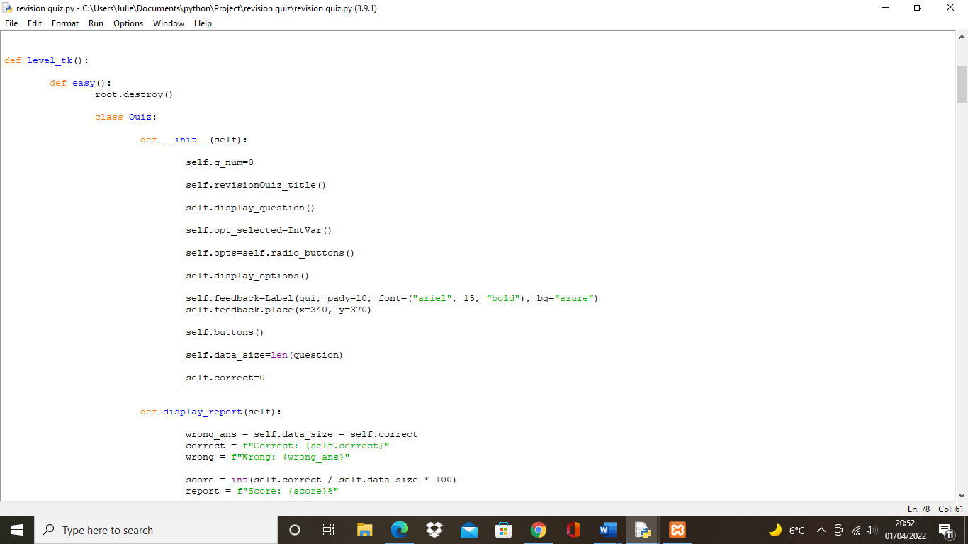

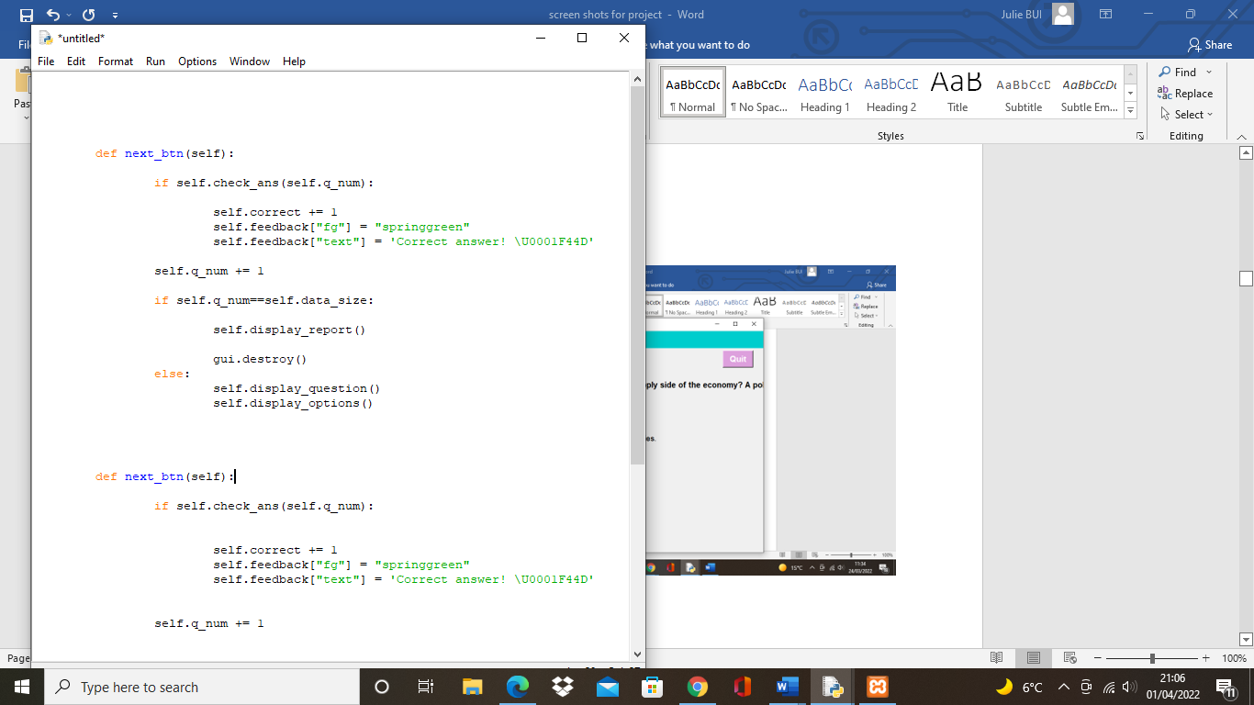

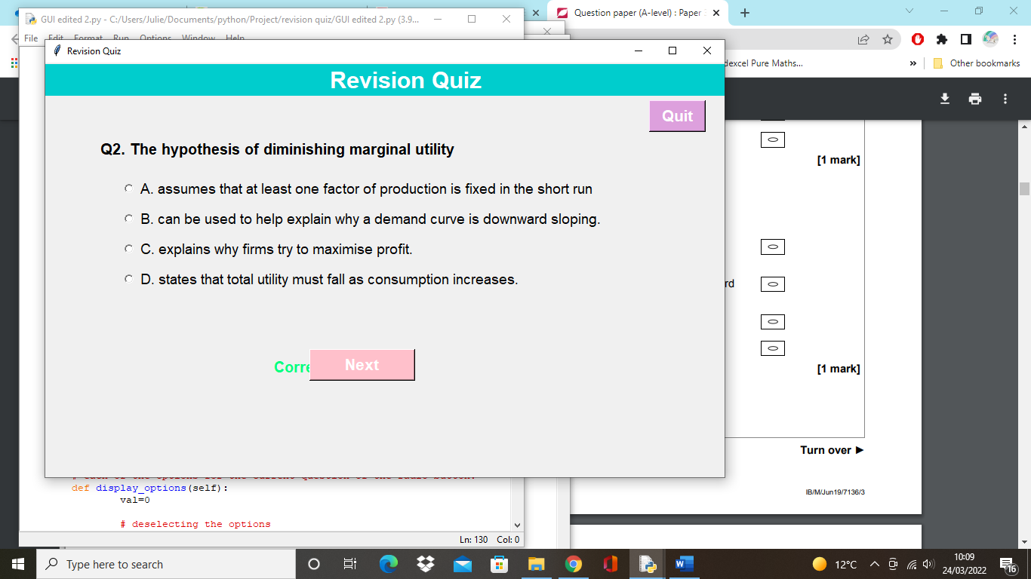The program would successfully output “Correct” but the next button would be covering it, this led me to change the position of the feedback.

Another problem was the program would output correct for all the answers even if it was wrong, however I added an else statement to output when the answer would be wrong and the correct output is shown.

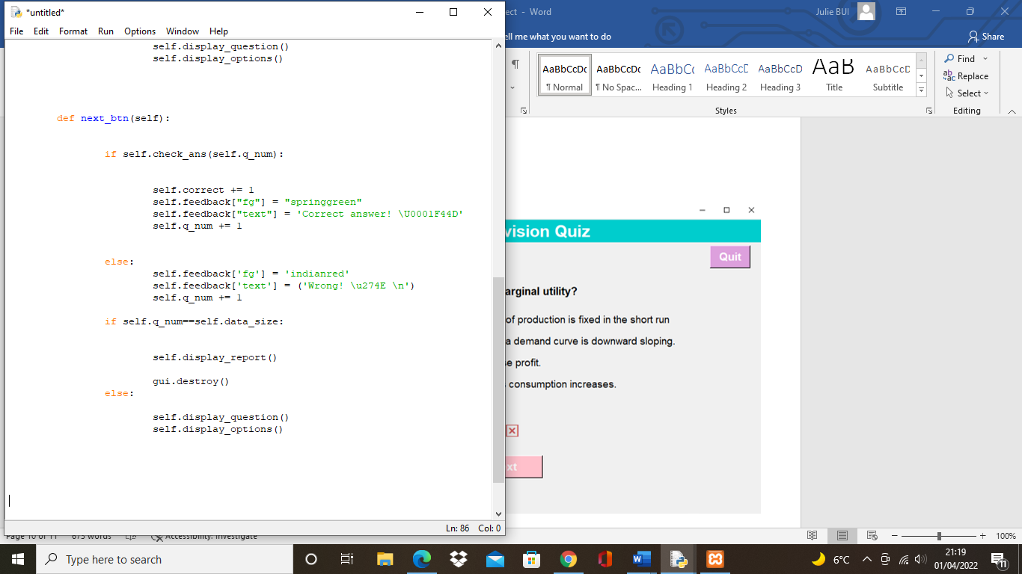

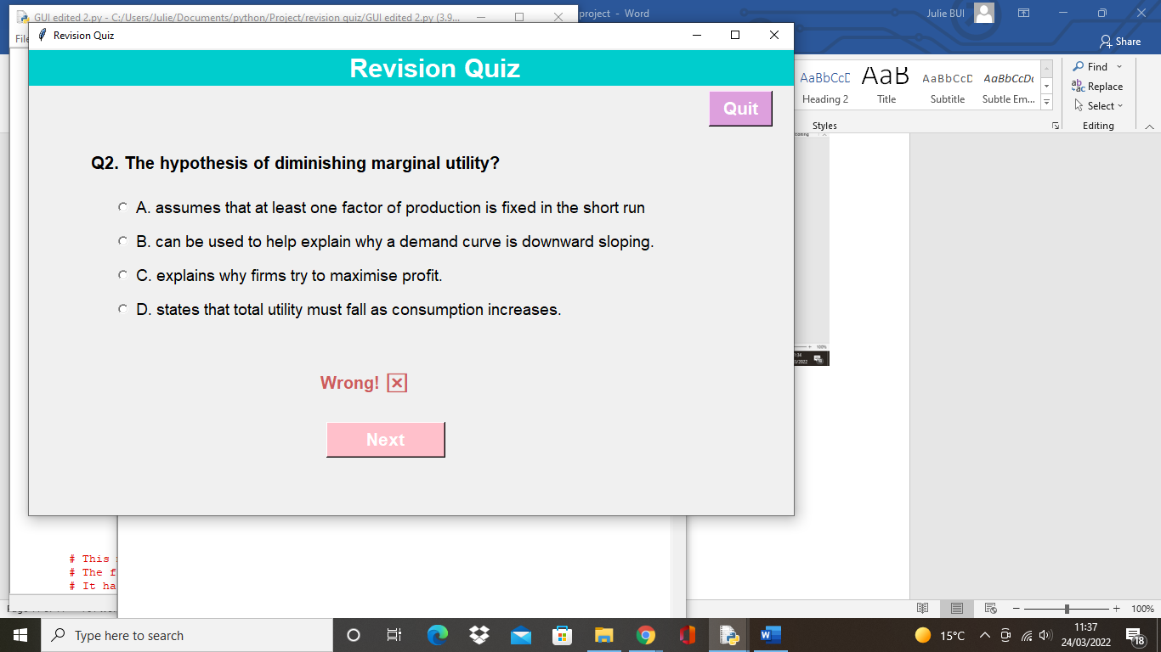

To make it an effective revision quiz, the program should be able to output what the correct answer is if the user answers wrong. Thus, I programmed the quiz to output the correct answer to the question number in {answer[self.q_num]} if the option the user selects is wrong.

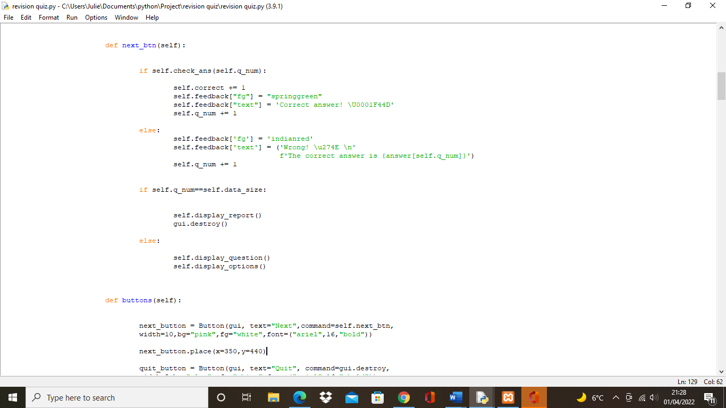

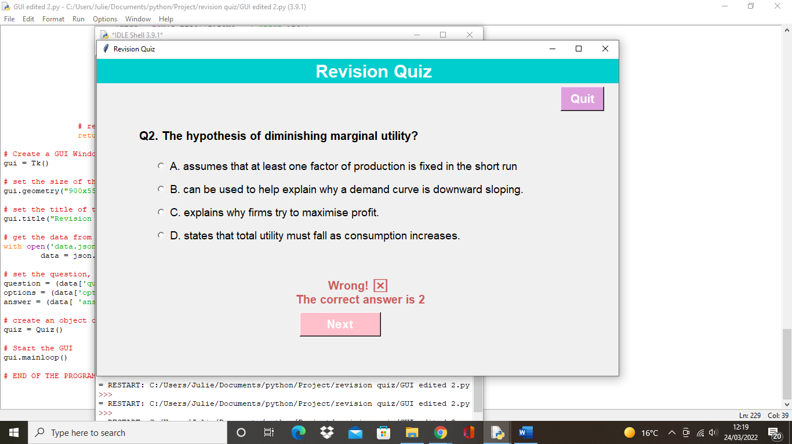

## Implementing the report

Another success criteria I had to implement was to display a report at the end of the quiz. The method works by calculating the number of wrong answers by subtracting the number of correct answers from the number of questions. The score is stored as an integer and calculates a percentage. This will be shown as a message box after the quiz has exceeded the number of questions.

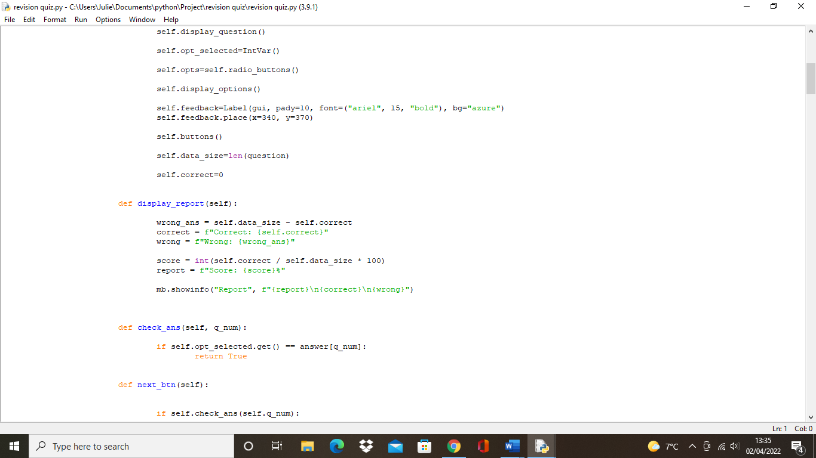

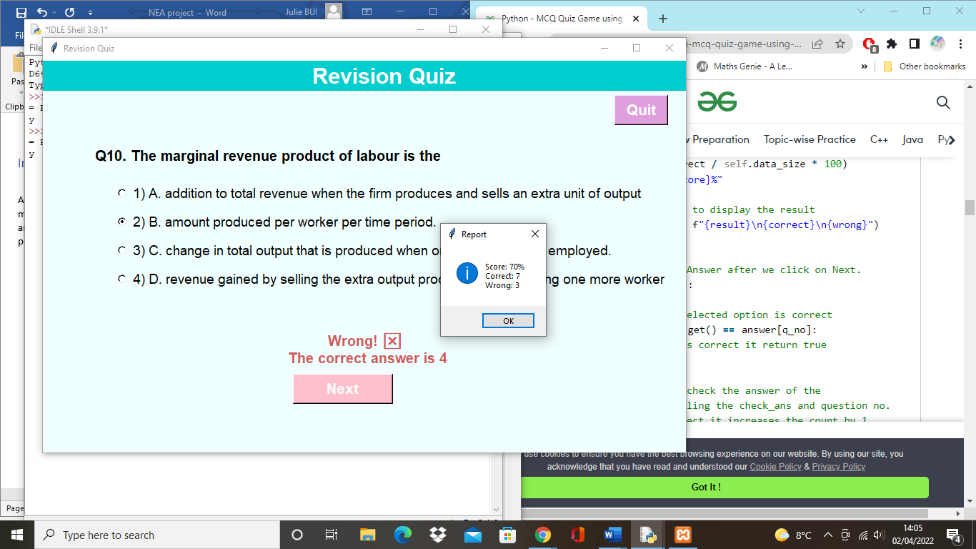

## Implementing the levels

For users to test their knowledge on certain levels I tried creating a levels page where users can click on an easy, medium or hard level and try the questions accordingly.

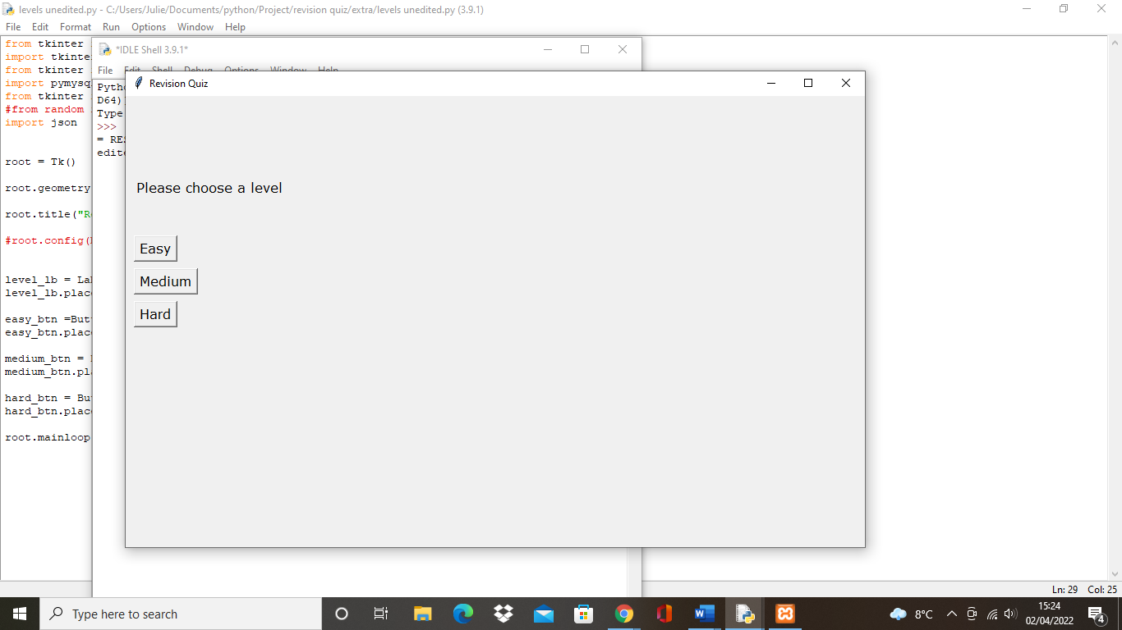

Firstly, I had to create a basic levels page with the buttons of easy, medium and hard.

Then, I created a separate json file for each level containing the questions and answers for each level

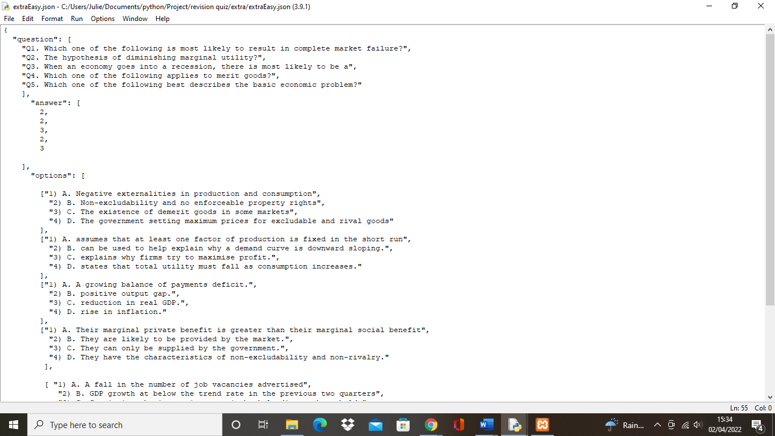

Example of the easy.json file

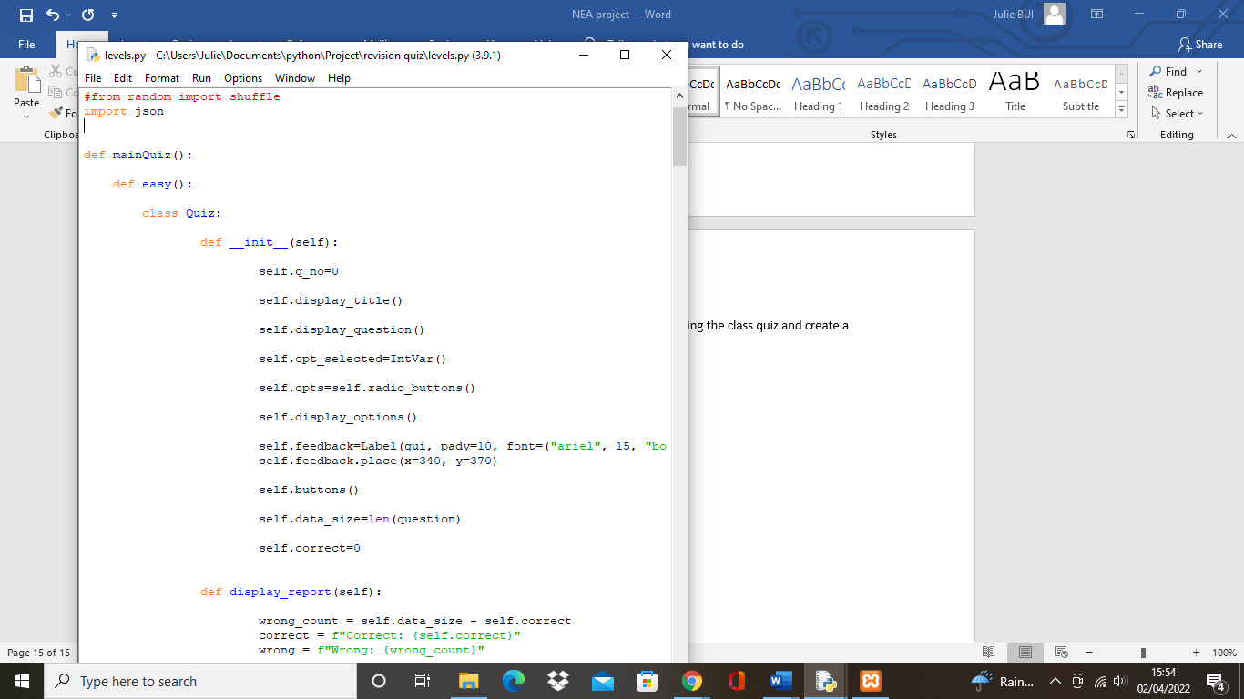

After, I had to join the levels page with the main file holding the class quiz and create a function for each level

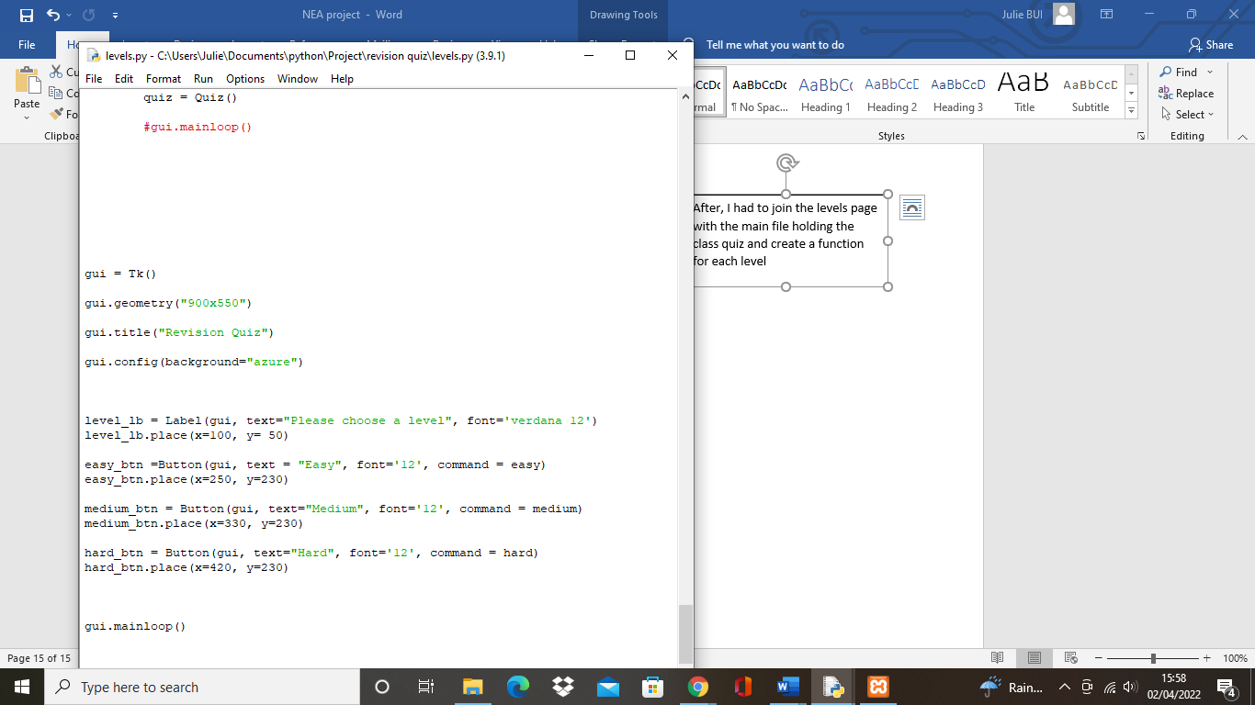

Levels page code

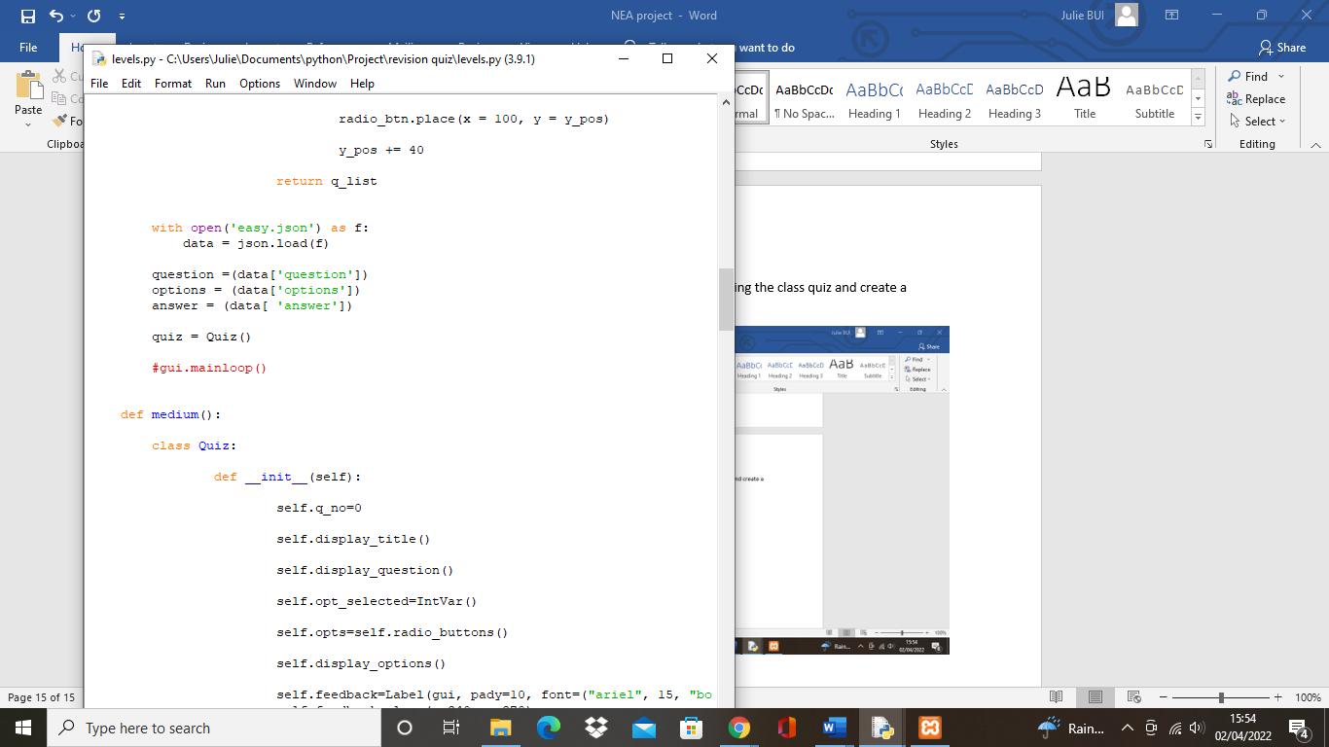

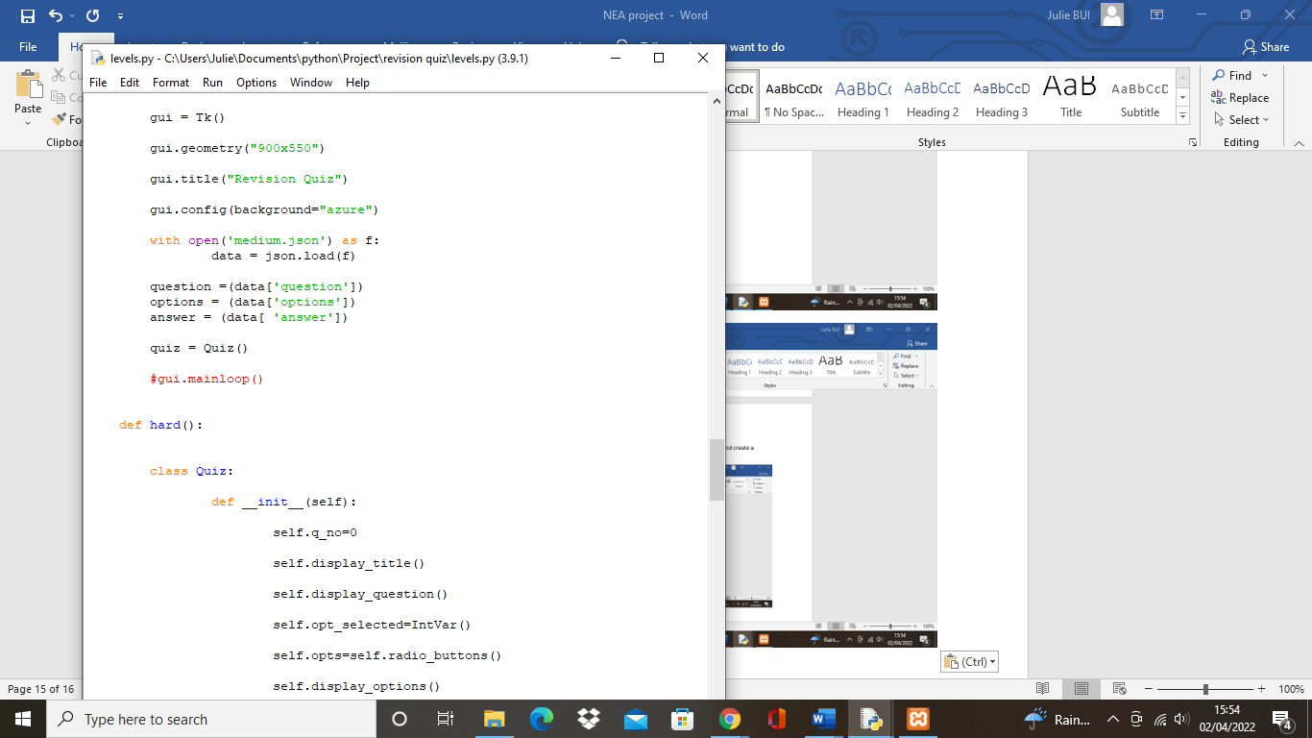

However, after I tried running the file an error occurred where the program didn’t recognise the easy function.

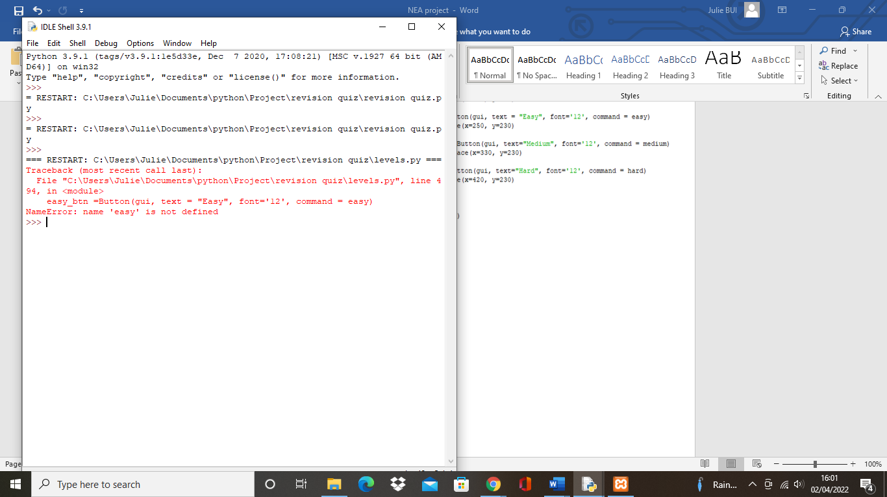

I then had to place the levels page code after the def mainQuiz() so the def easy() would run before the command=easy. But the quiz seemed to overlap with the levels window.

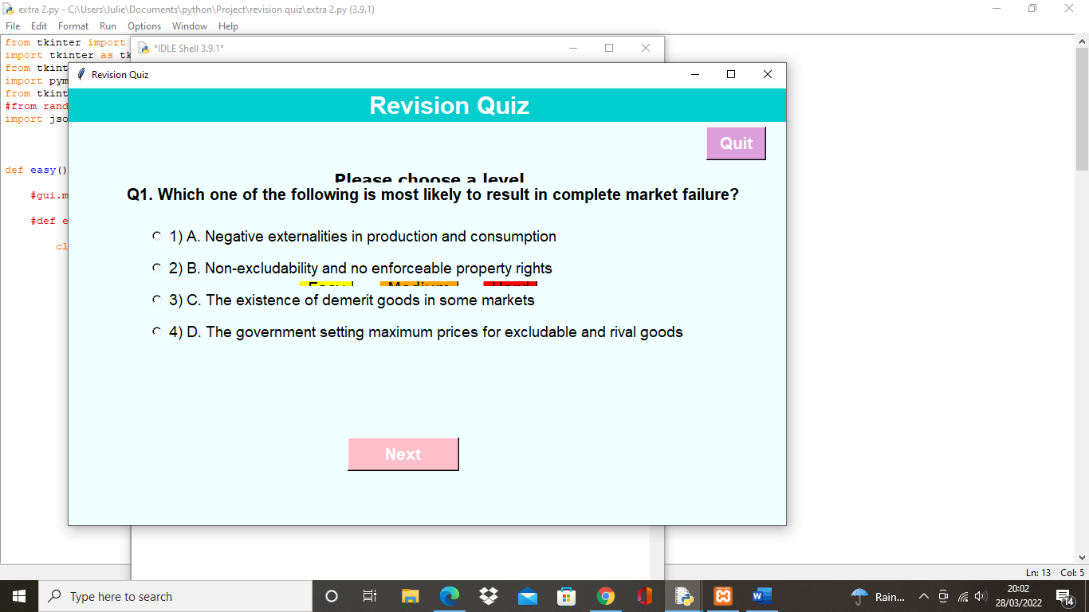

This was fixed by adding root.destroy after the def easy(), def medium() and def hard() so the levels window would destroy.

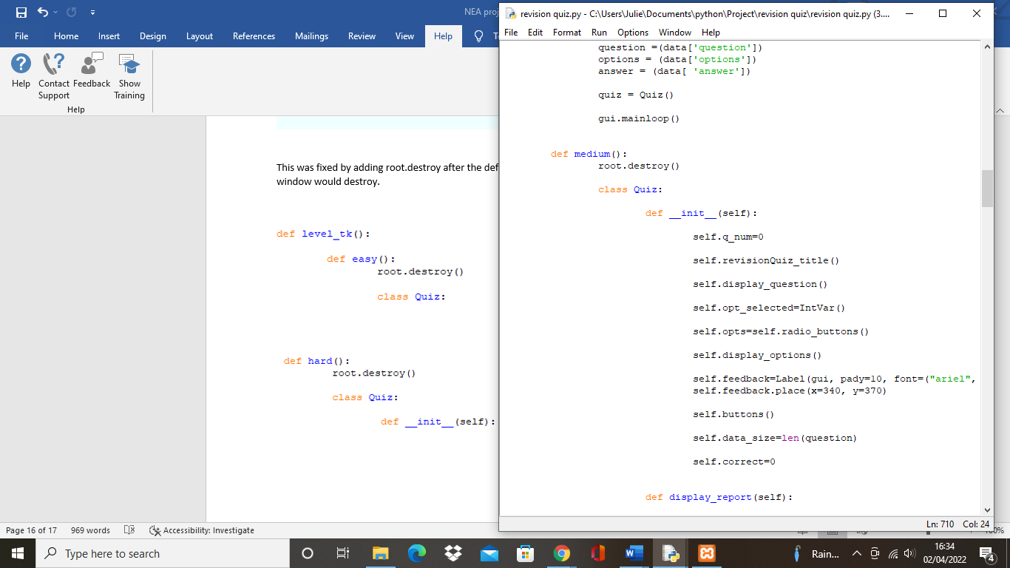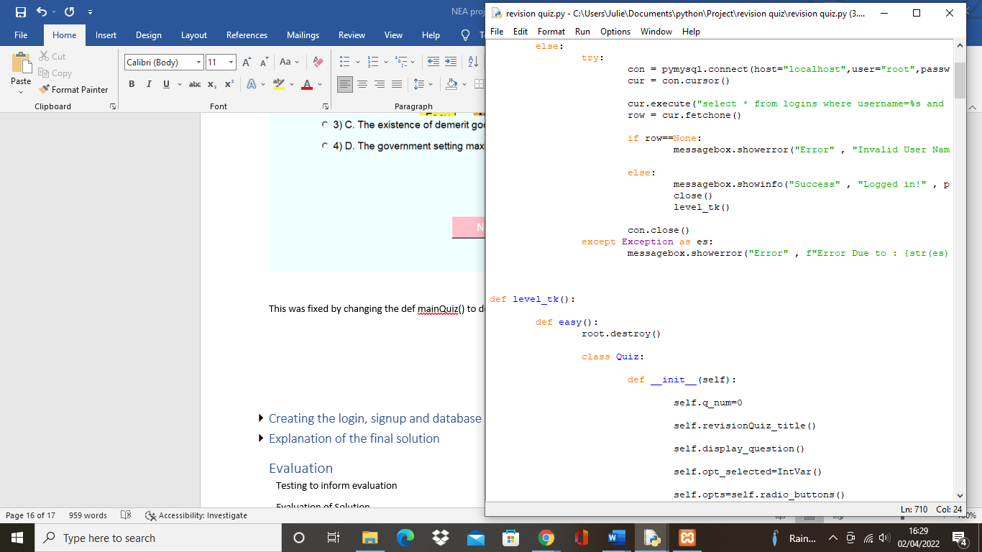

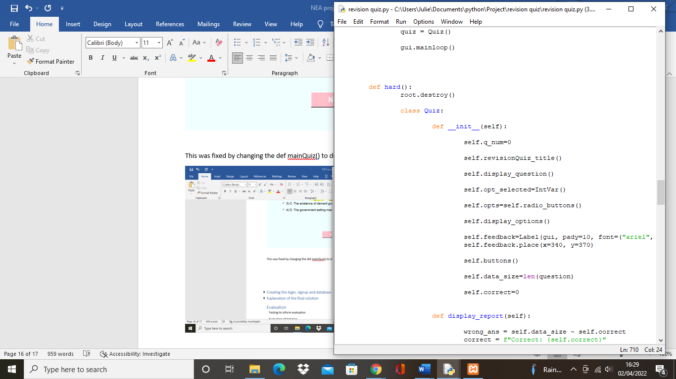

## Creating the login, signup and database[5]

To store the users’ details, I created a database using MySQL and phpMyAdmin.

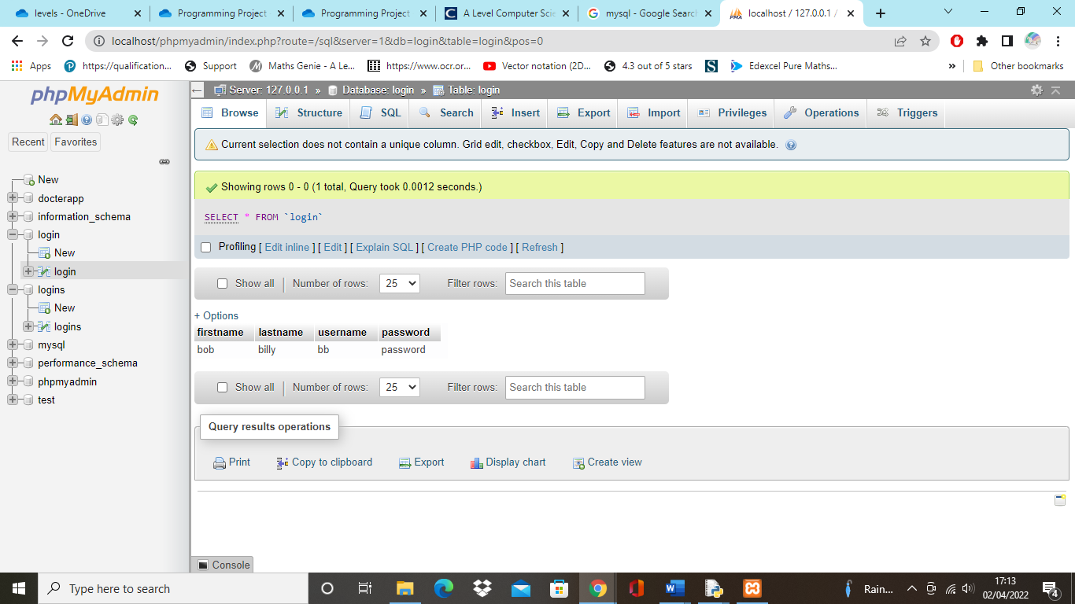

However, I realised I was unable to edit or delete the data in the database without including a primary key. This led me to create a primary key called “id” and I was successfully able to edit or delete data.

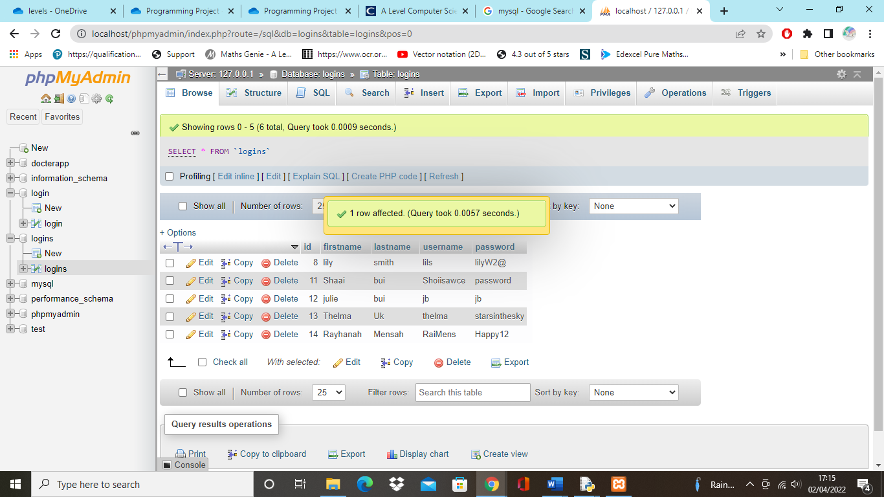

The data in the database were entered through the sign-up window I created.

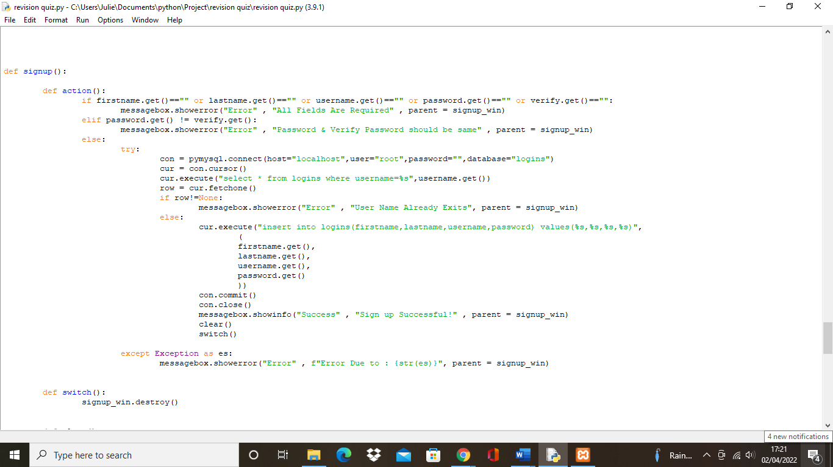

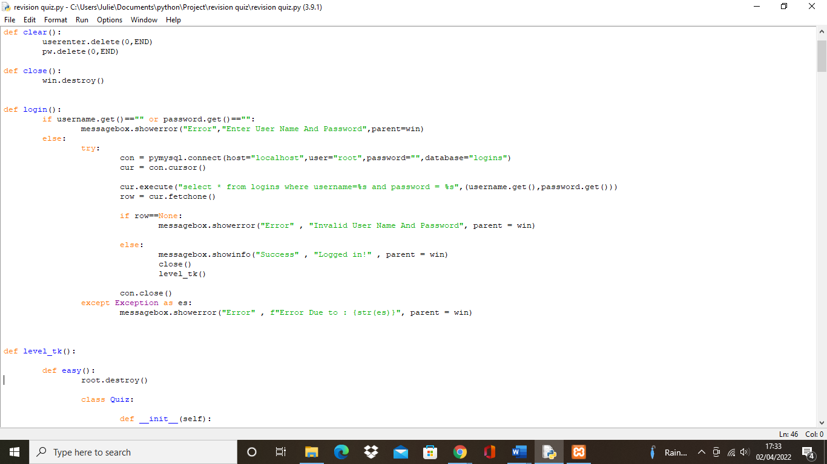The sign-up window would first create a message box where users would be able to enter their first name, last name, username and password. An error message would occur if the user has left any field empty or the message would warn the user if the password is not the same password as the verified password. The sign-up window would connect to the database and insert the first name, last name, username and password and a message would appear stating “Sign up successful”.

For the login page, when the user enters their username and password, the program will connect to the database and compare the username and password the user has entered with the username and password they registered with from the sign-up window. If the username or password is wrong, an error message will appear, whereas, if the username and password is the same, the message will state that it’s successful.

## Testing to inform development

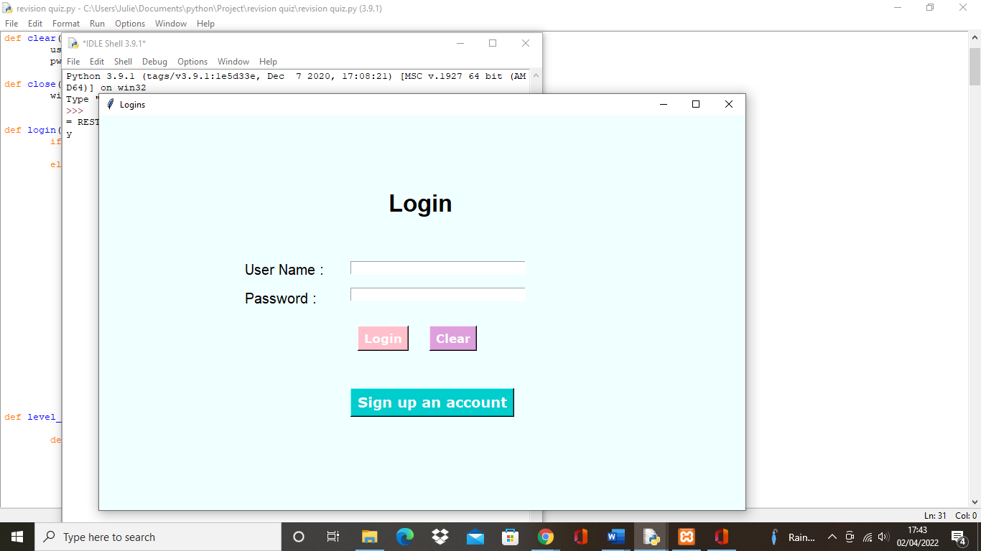Testing the logins and sign-up page with the database

The first window that appears after running the program is the login page.

Users are prompted to login if they already have their username and password

There is also an option to clear the entry box if users want to start over

If users haven’t registered their account, they can sign up by clicking the button and it will open the sign-up page

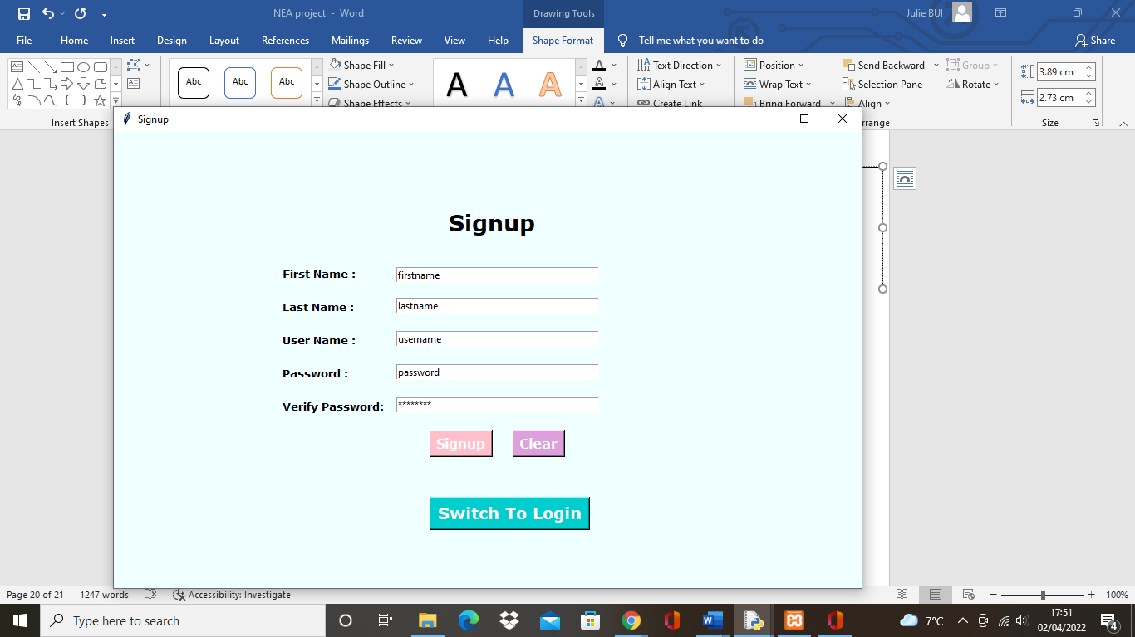

After clicking the sign-up button users can enter their details.

Users have an option to click the sign-up button when finished, the clear button to start over or to swich to login.

The verify password is also hidden for privacy

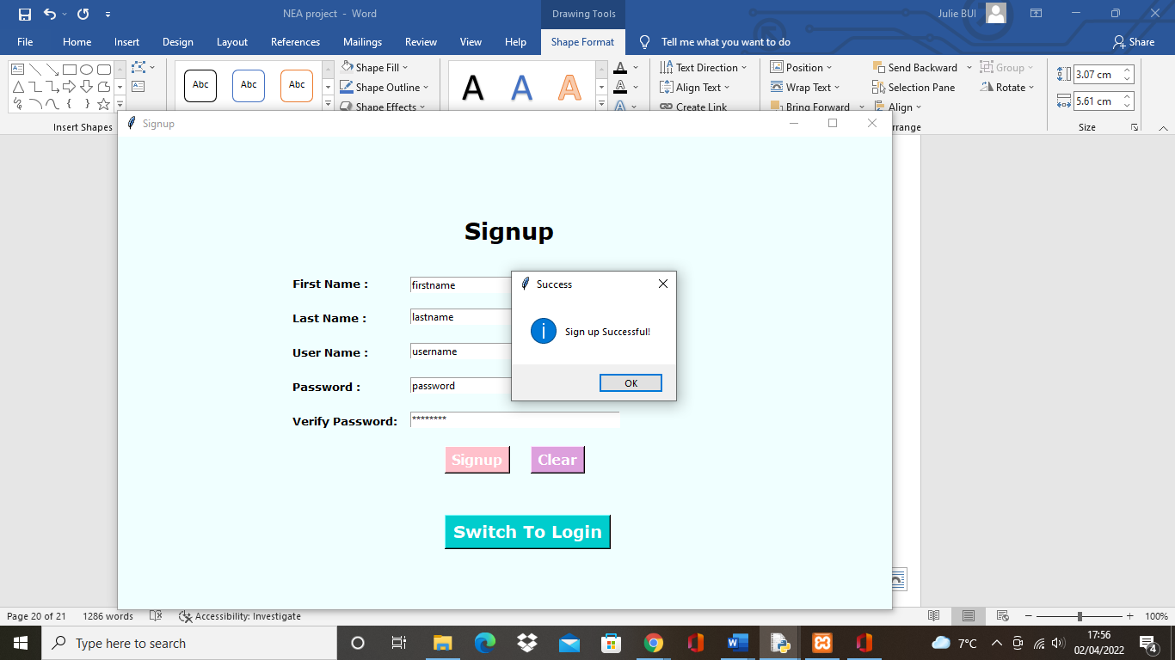

After clicking ok the sign-up window will close and users are now on the login page

Message box stating “sign up successful” after users click the sign-up button

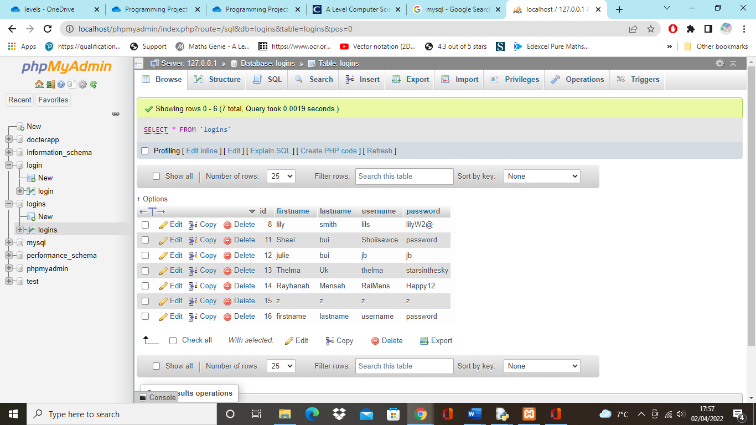

The details are then stored in the database

If an account with the same username exists it will state “user name already exists”

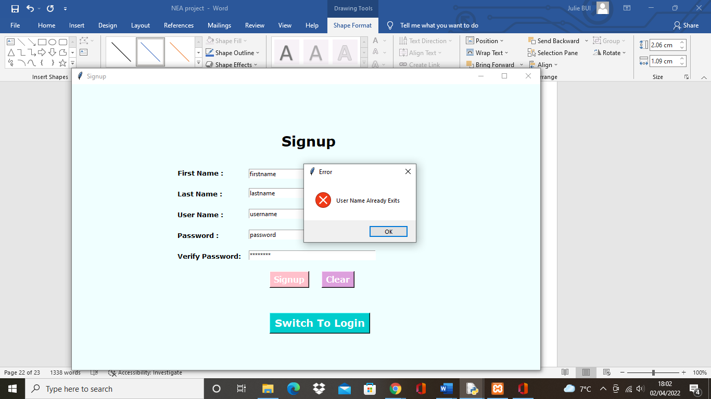

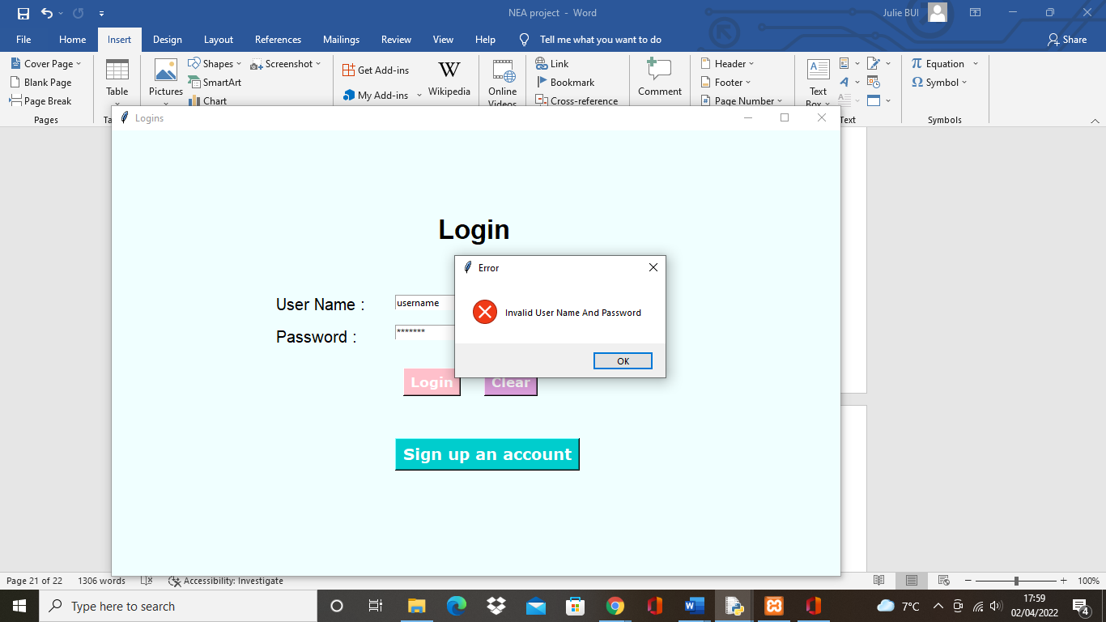

If the username and password is not matched with the one stored in the database it will state “invalid username and password”

If the username and password is correct it will state “logged in” after clicking the login button

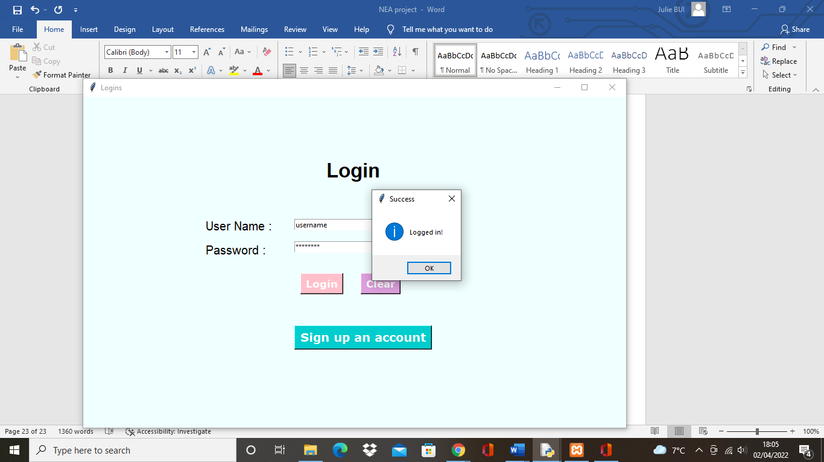

Testing the level page

The levels window will open after clicking the ok button. Users are able to choose between easy, medium and hard

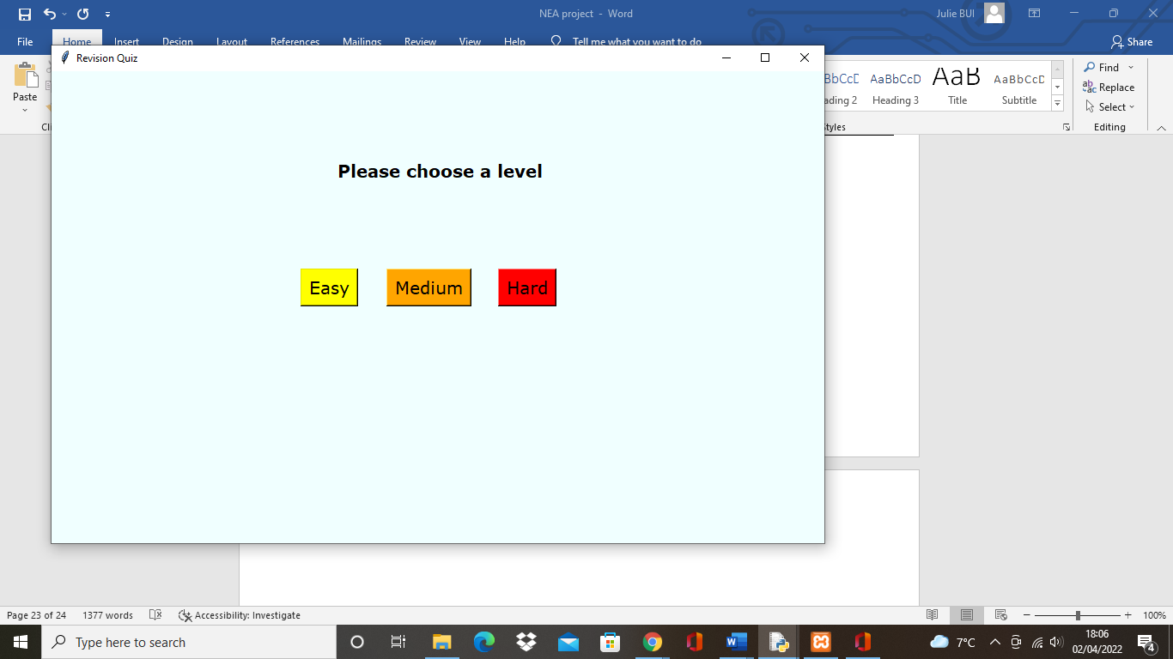

Testing the questions and answers

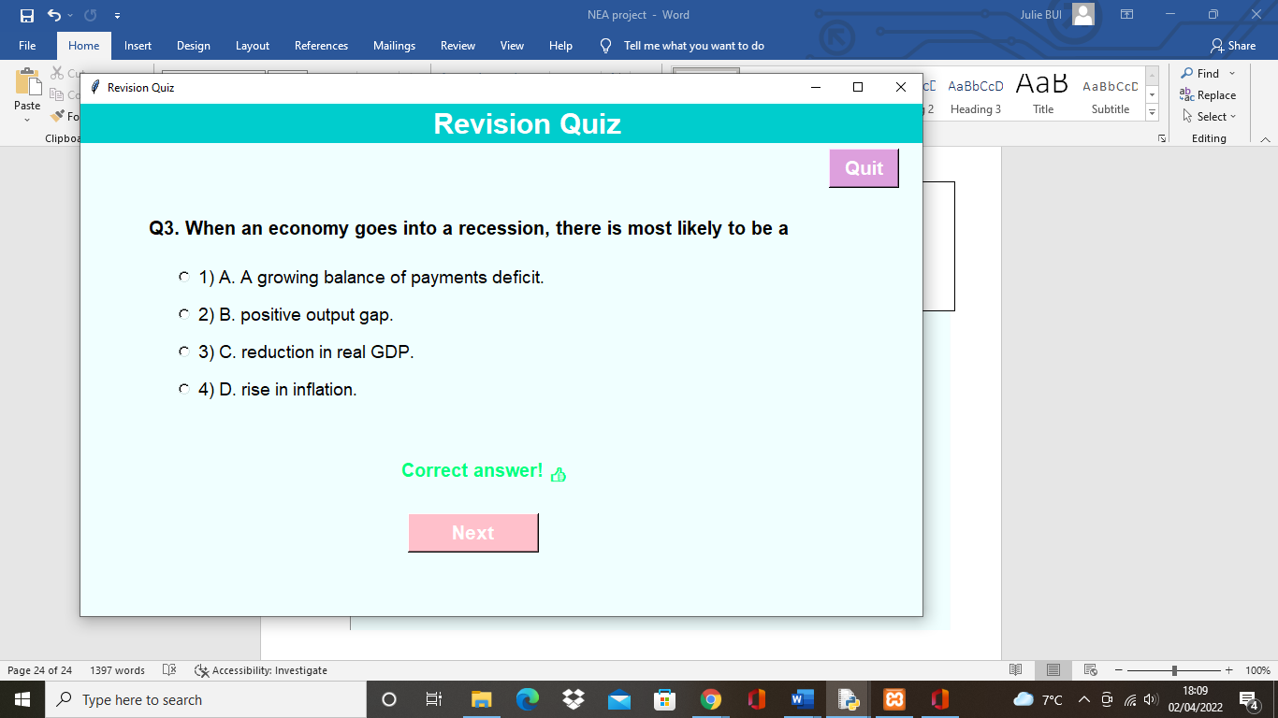

Users are also able to quit the game by clicking the quit button

After choosing a level the corresponding questions will appear

If the answer the user selects is right it will output “correct answer”

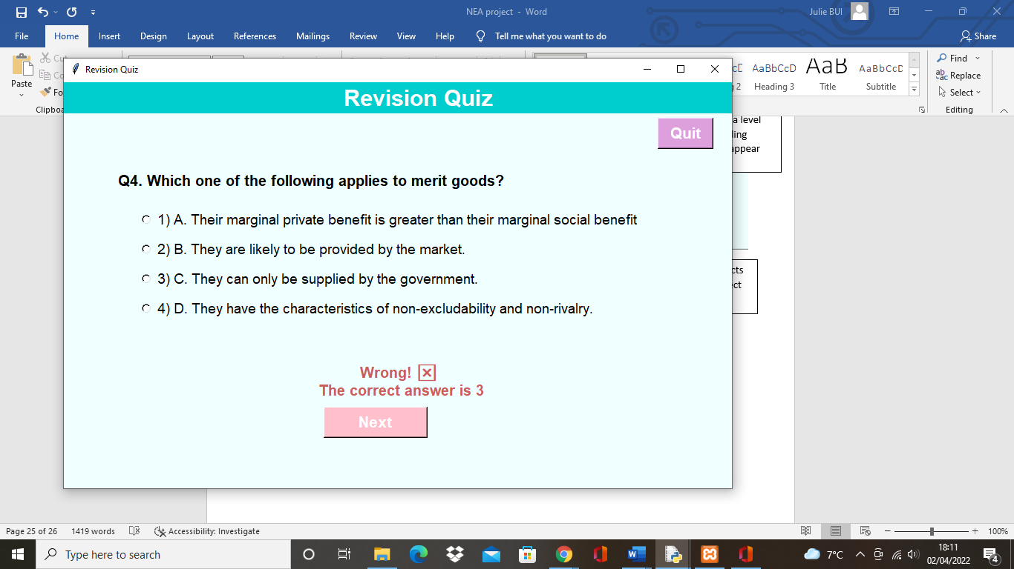

A message box will appear after the last question showing the report of the score and number of correct and wrong answers

If the answer is wrong users will be informed what the correct answer is

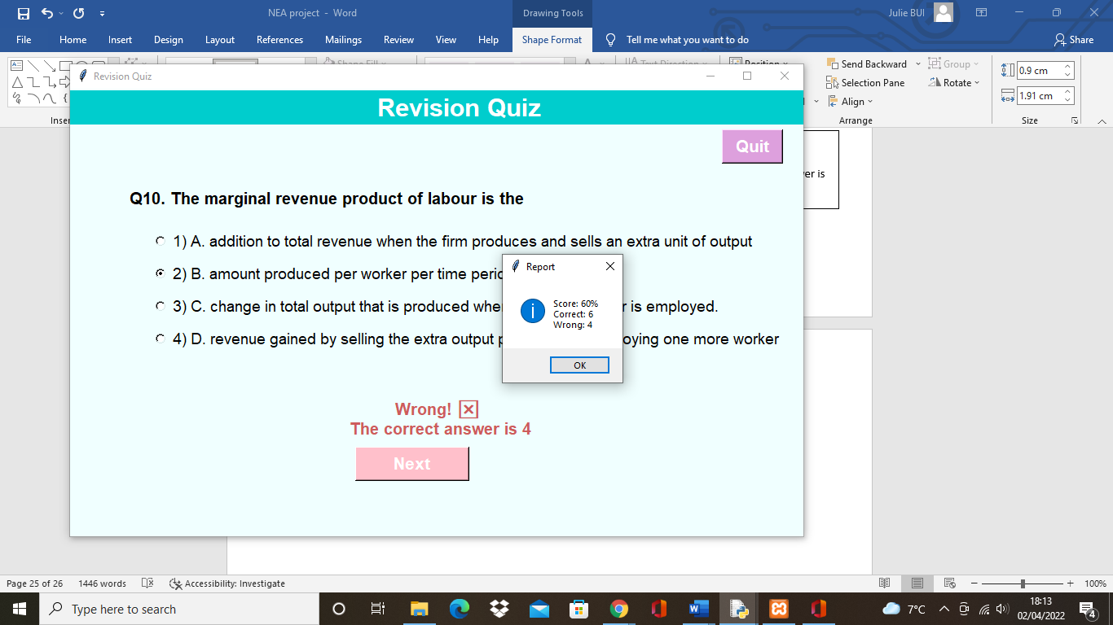

# Evaluation

## Evidence of success criteria

Success criteria 1: The program will be able to output the questions with the multiple-choice options

Evidence:

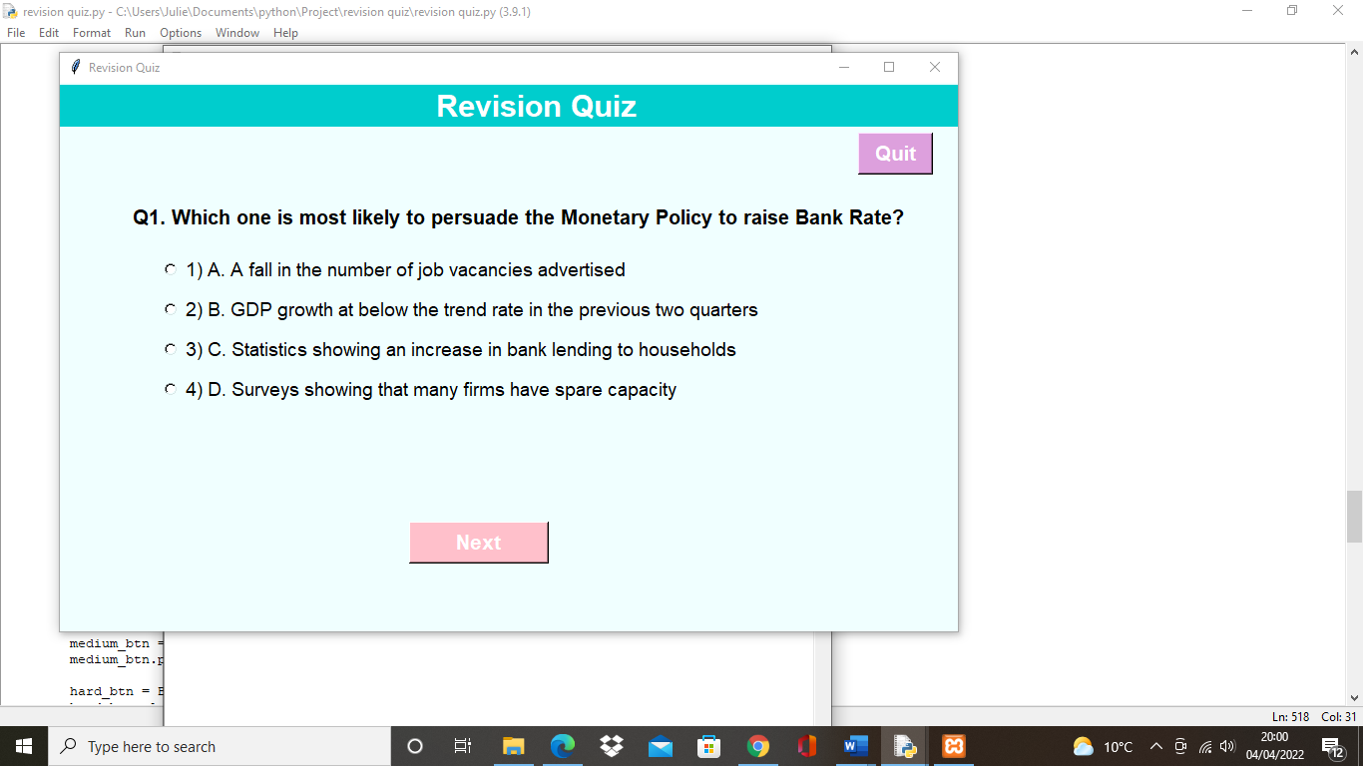

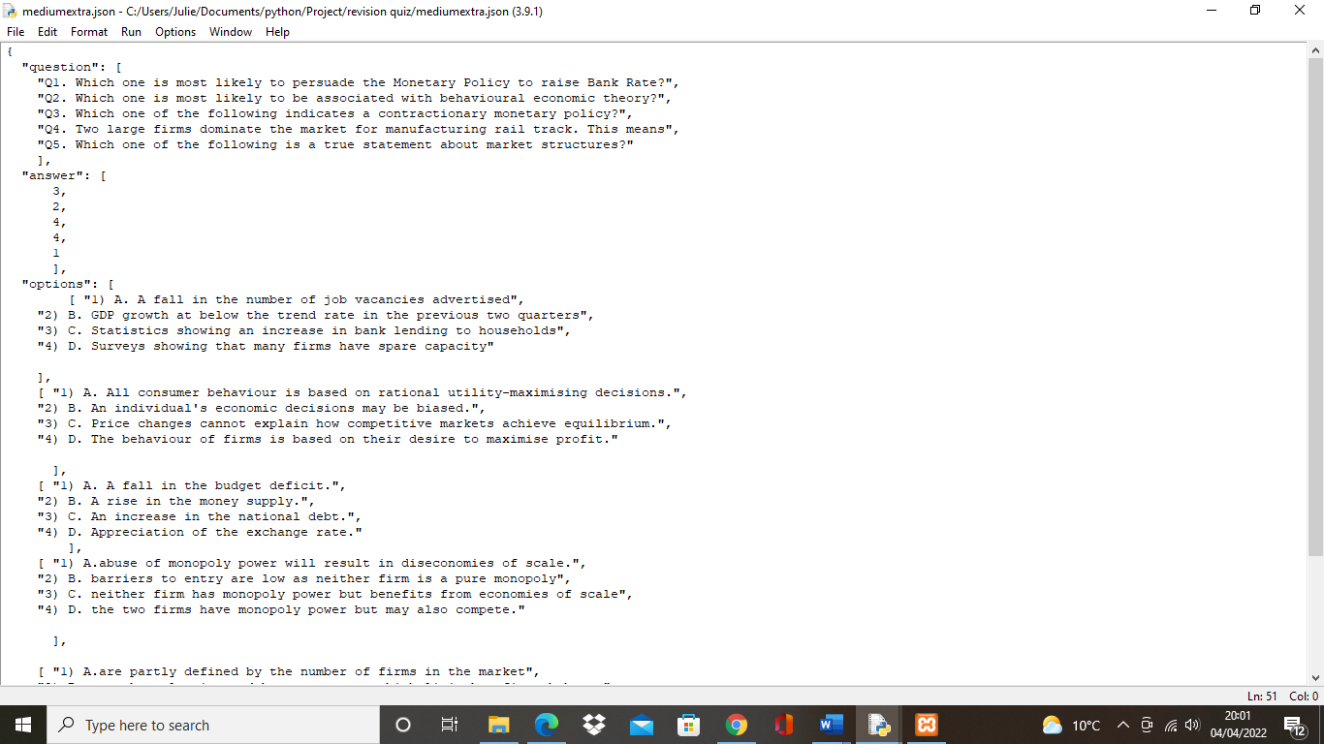

The screenshots above show the completion of the success criteria that has been met. This is because the question “Q1. Which one is most likely to persuade the Monetary Policy to raise Bank rate”, in the JSON file has successfully outputted onto the program with all the options also being shown.

Success criteria 2: the program will output whether it’s the right or wrong answer

Evidence:

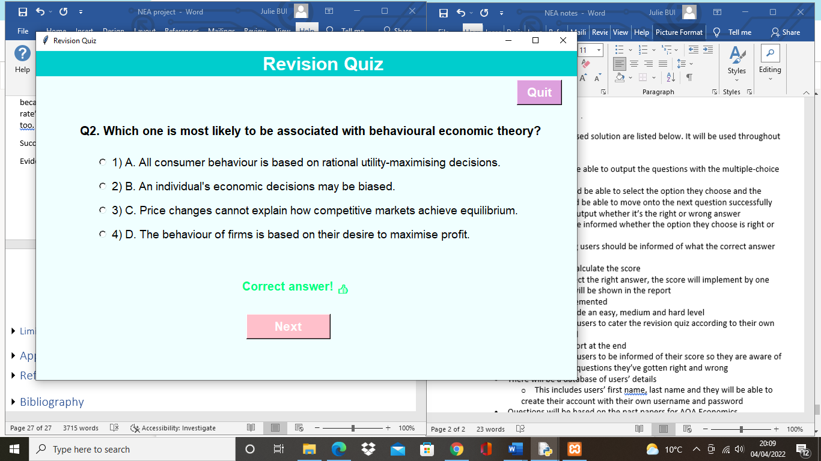

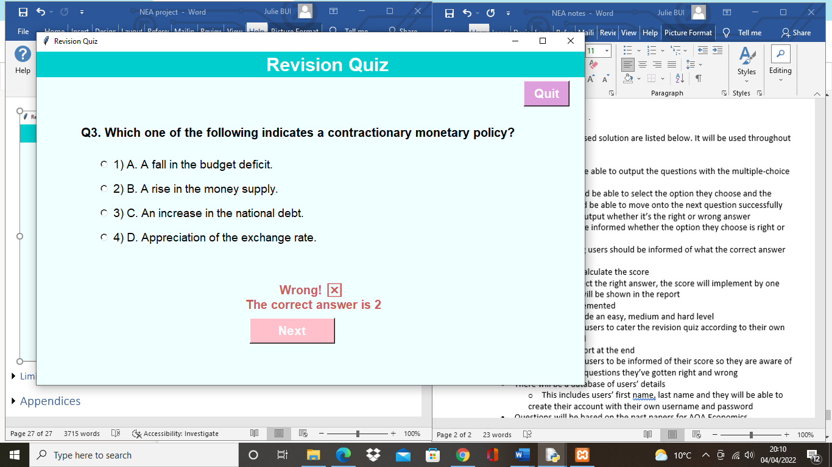

The screenshots show the success criteria has been met. This is because if the user gets a question right it will output it’s the correct answer and if the user gets it wrong, the program will output it’s the wrong answer with the correct answer.

Success criteria 3: the program will calculate the score



The screenshot shows the success criteria has been met because the report includes the score which the program has been able to output.

Success criteria 4: levels will be implemented

Evidence:



This success criteria have been met because the page outputs the options of the levels where users are able to choose between an easy, medium and hard level, and the following questions will appear.

Success criteria 5: there will be a report at the end

Evidence:



The success criteria have been met because the report successfully outputs with the score, number of correct answers and the number of wrong answers.

Success criteria 6: there will be a database of users’ details

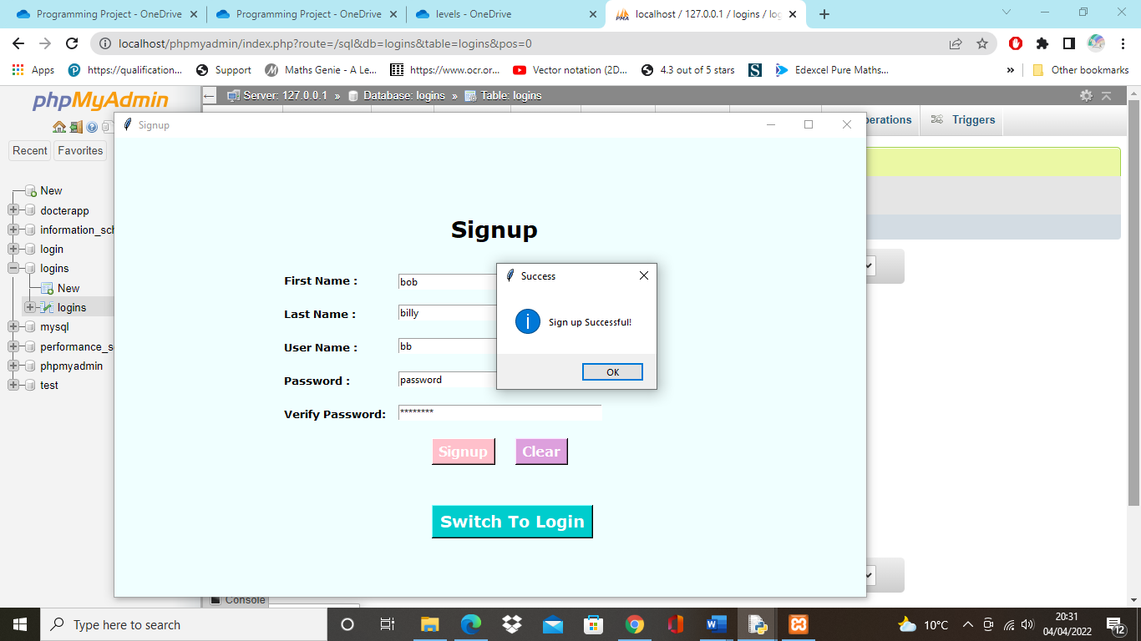

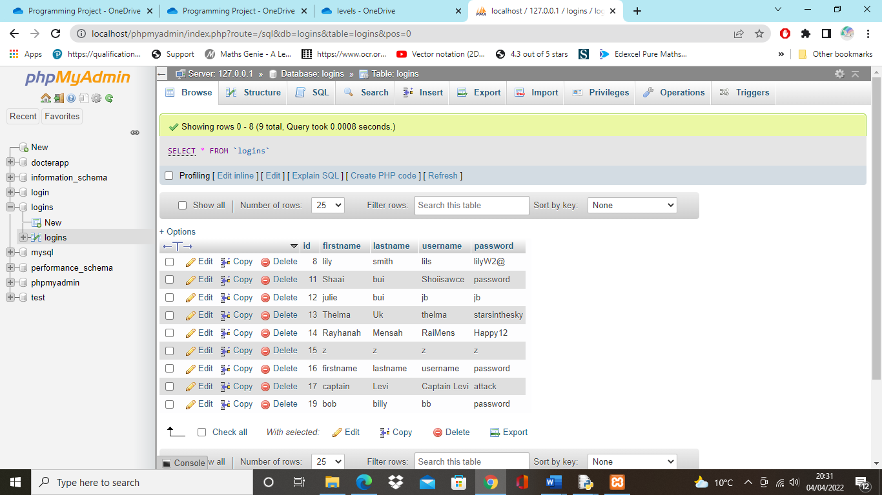

This success criteria have been met because if a user were to register an account, it would successfully output in the database with the correct details.

Success criteria 7: questions will be based on the past papers for AQA economics

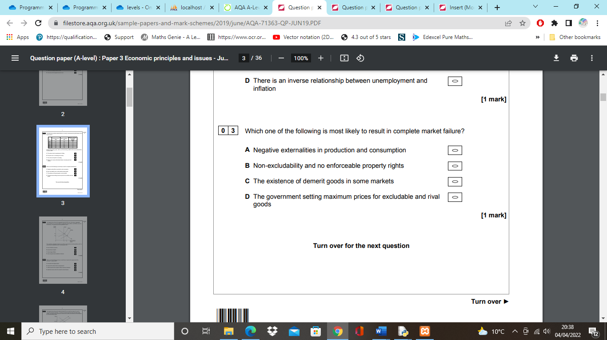

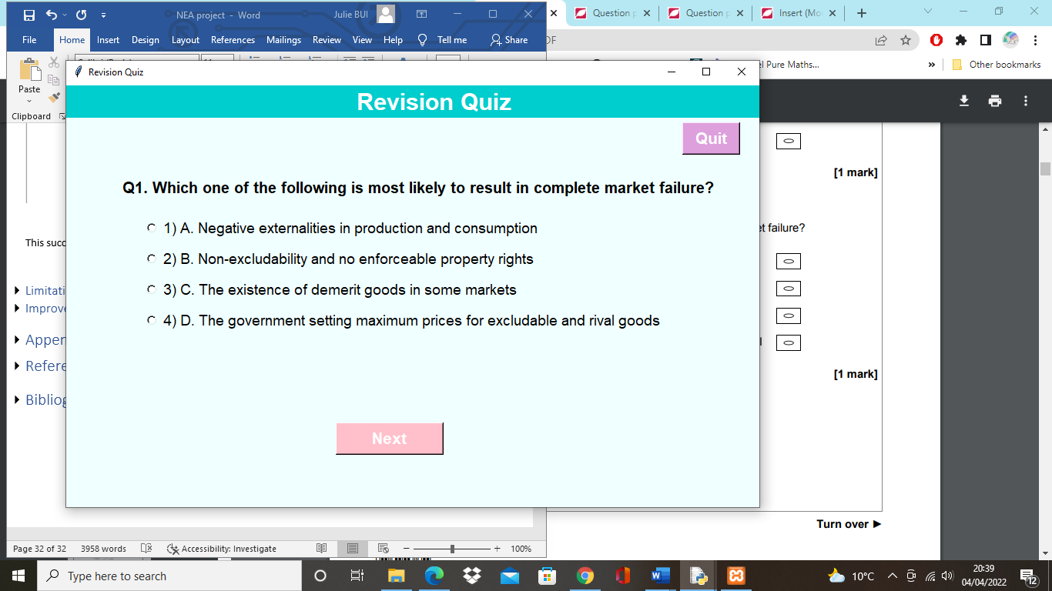

The success criteria have been met because as shown above, the questions have been based on the AQA past papers, providing relevant content to the users.

## Limitations and improvements with stakeholders’ interview

Although all the success criteria have been met, there are limitations of the program that could be further developed. One limitation is, although the program outputs what the correct should be if a user gets a question wrong, it only shows what the correct answer should be when the user has clicked the ‘next’ button and moved onto the next question. This is a limitation because the user may not understand why it is the correct answer if they are not able to see the question and correct answer together. However, it could be improved by implementing a ‘back’ button so users are able to see the question and correct answer together, by moving back to the previous window. Furthermore, whilst showing the program to the stakeholders, I noticed users had difficulty signing up. This is because as the program runs, it first opens up to the login page with a signup button, but it may not have been clear to the user they had to register an account first, or they did not see the signup button, as some stakeholders tried to login without having signed up an account. What could be improved is, I could start the program with a menu page where users have the options to login or signup, instead of the program starting up with the login page. This would be implemented by placing a ‘login’ button and ‘signup’ button which would open the following windows for the button the user selects, and would clear any misunderstanding the user has for logging in or signing up. In addition, whilst presenting the program to the stakeholders, it was mentioned that the revision quiz could be more helpful by including a hint section or explanation of the correct answer, if a user gets a question wrong. An idea of how this could be implemented is, there could be a hint button in the left corner of the screen where users are able to click on for every question, and it would provide a short fact on the topic the question is based on. In addition, if a user gets a question wrong, a message box with an explanation of the correct answer could be implemented when the program outputs “Wrong answer, the correct answer is…”. Furthermore, a limitation of the program is, the software required for the database may not be suitable as users would need to download the “Xampp control panel” for MySQL to work. This is a limitation because the revision game is not quite accessible and requires installations.

In addition, a limitation that the revision quiz had was the questions were limited as they only had a set number of 10 questions. This meant that the program could be too short, however, to overcome this, more questions but this may not be effective if users are repeating questions of the same level. Thus, this could be solved by implementing a new window at the end where users have an option to quit the quiz, or go back to the levels page and continue with questions from different levels.

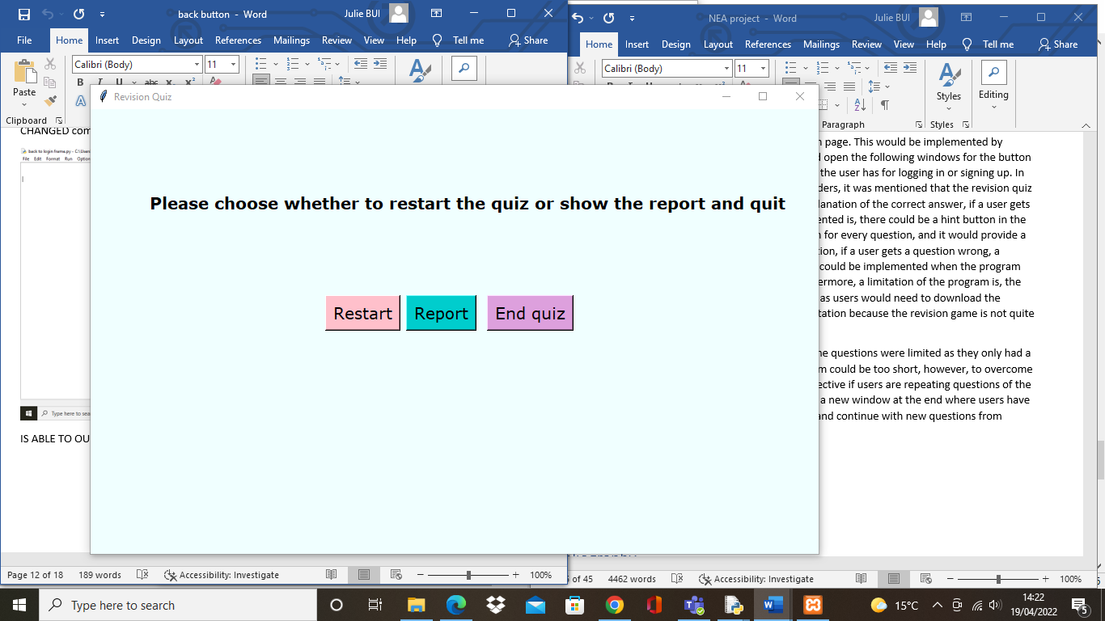

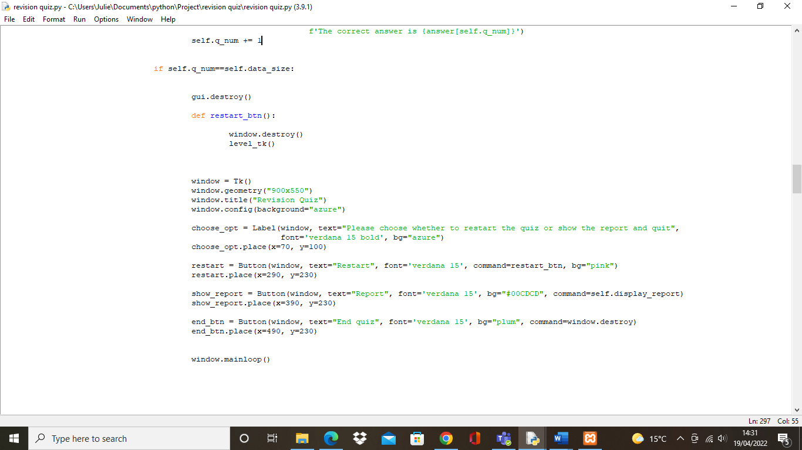

If users chose to quit the quiz, they would click the “End quiz” button and the program will end. Or, if they could see their report by clicking the “Report” button and it would output the results and they also have an option of restarting the quiz, this also make it more convenient for users as they won’t have to run the program again.

# References

1. <https://www.tutor2u.net/economics/reference/20-multi-choice-questions-on-any-topic-revision-for-paper-3>
2. <https://www.economicsonline.co.uk/quiz/quiz-introduction-to-economics.html/>
3. <https://www.geeksforgeeks.org/python-mcq-quiz-game-using-tkinter/>
4. <https://www.aqa.org.uk/subjects/economics/as-and-a-level/economics-7135-7136/assessment-resources>
5. <https://masterprograming.com/tkinter-login-and-registration-form-with-database/>